**Web Application Inventory Management System**

**for Jernixon Motorparts and Accessories**

An IT Project Proposal

Presented to the

Faculty of the School of Computing and Information Sciences

Saint Louis University

In Partial Fulfillment

of the Requirements for the Course

IT 421

by

Joshua James A. Abalos

Randy Ezekiel S. Antero Jr.

Marinel C. Baucas

Nonito E. Cabilar Jr.

Engelyn B. Carreon

Kenneth D. Jaramel

Jake James G. Manzon

Caesar Jim V. Romero

Roderick Makil

Project Adviser

May 2018

# Abstract

Jernixon Motorparts is a shop that offers various motorcycle parts and accessories, at the same time accepts motorcycle repairs. The business conducts business in Pangasinan with its main branch in Alaminos City and the other branch in Bani.

The main branch operates using manual system to manage its daily business operations and transactions. Due to increase of their stocks, the manual system is no longer effective for the shop anymore. The company also lacks operation-related reports that can help the owner to properly decide on matters like slow-moving items.

Automation of the current system in monitoring of the Jernixon Motorparts inventory items is the purpose of the project. A web-based inventory monitoring system is being proposed comprising of two user modules: admin and sales assistant. Aside from addressing the business’ needs in managing the inventory, it should also generate the needed output for the owner to gain insight on which items need to be restocked, items that have a high volume of sales, and others.

The software engineering methodology to be adopted by the group will be Waterfall model. In this model, development proceeds from one phase to the next in a sequential manner. These phases include: analysis, design, development, testing, and deployment.

For the outcomes and results of the project, the team extracted the functional and non-functional requirements based on the gathered data and document review. The project team also created the system and software design using the functional and non-functional requirements. In the project development, the project used different tools and technology to create the web-based application. For the application testing the team conducted a manual functional testing. And for the deployment of the project, the team will also train or orient the eventual users of the web-based inventory management system of the Jernixon Motorparts and Accessories.

# Table of Contents

Abstract ii

Table of Contents iii

List of Figures v

List of Tables vi

Chapter 1: Introduction 1

1.1 Context of the Study 1

1.1.1 Inventory Management System 1

1.1.2 Web Application Inventory Management System 1

1.2 Background 2

1.2.1 Company Profile 2

1.2.2 Current Business Process 3

1.2.3 Problems Encountered in the Current Operations 7

1.3 Statement of Objectives 8

1.4 Scope of the Project 8

1.5 Significance of Study 8

Chapter 2: Methodology 9

2.1 Requirements Gathering and Analysis 9

2.2 System and Software Design 10

2.2.1 System Design 10

2.2.2 Software Design 10

2.3 Development of the System 10

2.3.1 Development 10

2.3.2 Timetable and Roles of members 10

2.3.3 System Testing 11

2.4 Deployment of the System 11

Chapter 3: Outcomes and Results 12

3.1 Analysis 12

3.1.1 Functional Requirements 12

3.1.2 Non-Functional Requirements 13

3.2.1 System Design 14

3.2.2 Software Design 22

3.3 Development and Testing 39

3.3.1 Development phase tools 39

3.3.2 Development phase technologies 40

3.3.3 Hardware 41

3.3.4 Timetable and Roles of members 41

3.3.5 System Testing 42

3.4 Deployment of the System 42

Chapter 4: Conclusion 43

4.1 Conclusion 43

4.1.1 Recommendation 43

References: 44

Attachment/Appendix 45

Appendix A: Transcript of Interviews 45

Appendix B: Delivery receipt 48

Appendix C: Invoice receipt by supplier 50

Appendix E: Sample list of products 53

Appendix F: Sales list 61

# List of Figures

Figure 1: Jernixon Motorparts and Accessories Organizational Chart 2

Figure 2: Purchasing of Stocks Directly from the Supplier 3

Figure 3: Return of damaged items within the warranty period 4

Figure 4: Replacement of damaged item before purchasing the products. 4

Figure 5: Purchasing of Stocks by E-mail or Text message 5

Figure 6:Purchasing of Stocks by E-mail or Text message with Return 5

Figure 7: Selling of items 6

Figure 8: Return from the customer 7

Figure 9: Damaged Items 7

Figure 10: Waterfall Model 9

Figure 11: Entity Relationship Diagram 15

Figure 12: Data Flow Diagram 17

Figure 13: Use Case Diagram 21

Figure 14: System Architecture 22

Figure 15: Admin Login 22

Figure 16: Admin Dashboard 1 23

Figure 17: Admin Dashboard 2 23

Figure 18: Admin Report 24

Figure 19: Admin Notification 24

Figure 20: Admin Item - 1 25

Figure 21: Admin Item - 2 25

Figure 22: Admin Item - 3 26

Figure 23: Admin Item - 4 26

Figure 24: Admin Item - 5 27

Figure 25: Admin Employee 1 27

Figure 26: Admin Employee 2 28

Figure 27: Admin Sales 1 28

Figure 28: Admin Sales 2 29

Figure 29: Purchase 1 29

Figure 30: Purchase 2 30

Figure 31: Admin Return 1 30

Figure 32: Admin Return 2 31

Figure 33: Admin Return 3 31

Figure 34: Admin Return 4 33

Figure 35: Sales Assistant Login 35

Figure 36: Sales Assistant Sales Items 1 36

Figure 37:Sales Assistant Sales Items 2 37

Figure 38: Sales Assistant Return 1 37

Figure 39:Sales Assistant Return 2 37

Figure 40: Sales Assistant Return 3 39

Figure 41: Sales Assistant Stock Adjustments 39

Figure 42: Sales Assistant Stock Adjustments 40

Figure 43: Sales Assistant Physical Count 40

Figure 44: IT Project 1 Schedule 43

Figure 45:IT Project 2 Schedule 43

Figure 46: Timetable 44

Figure 47: Specific Role of the members 44

# List of Tables

Table 1: Functional Requirements 13

Table 2: Non-Functional Requirements 14

Table 3: Data dictionary 18

Table 4: Development phase tools 39

Table 5: Development phase technologies 40

Table 6: Hardware 41

# Chapter 1: Introduction

This chapter discuss the context of study, company background, objectives in the development of the application, scope of the project, problems encountered and the significance of the study.

## 1.1 Context of the Study

Retailing is the process of buying products from the suppliers or wholesalers and then selling it directly to final consumers (Kotler & Armstrong, 1999). The retailers must be able to manage every single item in their inventory in order for the business to be successful.

An inventory system is a process of monitoring the flow of goods, including the monitoring of items in the stockroom and maintaining inventory levels so that the items will not be out of stock.

In today’s era, everyone use technology and almost all of the systems are web-based. A web application is a program that runs on a web server, while its users interact with it via a web browser or a similar user agent (Doaa Nabil et al, 2011).

### 1.1.1 Inventory Management System

Inventory system provides information about a certain item such as price, name of supplier, date of purchase, date of sale, quantity and also provides information about the products that are low on stock (F. Robert Jacobs and Richard B. Chase, 2013). The system tracks the fast-moving item and slow-moving items in order to have an idea what items are popular to the customer. It is faster than the manual system, it lessens the human error and could accurately give information about the current inventory levels (Cambronero et al, 2010).

### 1.1.2 Web Application Inventory Management System

Web-based inventory system is a computer-based application that keeps track of the stock levels and sales of the inventory of the business. A web application is a software program that uses a web browser such as Google Chrome, Firefox and others to perform tasks such as retrieving, sending and modifying data (Nations, 2017). An example of web-based application is Zoho inventory, an online inventory system that generates reports, gives summary, creates inventory items, and records restocking of items. The generated summary is about the highest selling, low stock, and the quantities of the items (Zoho, 2015).

## 1.2 Background

### 1.2.1 Company Profile

Jernixon Motorparts and Accessories was established in the month of September year 2015. The business is a repair shop of motorcycles and at the same time, sells parts and accessories for motorcycles. It was once called J3 Motorparts and Accessories and is formally called Jernixon Motorparts and Accessories in the year 2016. It is located at Sadsaran, Poblacion, Alaminos City, Pangasinan at a rented space near the town of Alaminos City. As years passed, the business was able to establish their second branch located at Poblacion, Bani, Pangasinan, a few kilometers away from the main branch.

The business is selling two types of products, motorcycle parts such as chains, battery, muffler, side mirror, disc brake *(see sample list of products in Appendix E)* and motorcycle accessories such as stickers, seat covers, handlebar, helmets *(see sample list of products in Appendix E)*. When they first started the business, they only have about five hundred to six hundred (500-600) items. As the business grew, they are now selling approximately one thousand (1000) different items and stored at the branch itself. The business is also engaged in repairs and services such as overhaul, change oil, tune up, wirings and set-up.

The project will focus on the main branch, which currently has four staff members, two mechanics, one sales assistant, and one general manager/owner. Figure 1 shows the organizational chart of Jernixon Motorparts and Accessories.

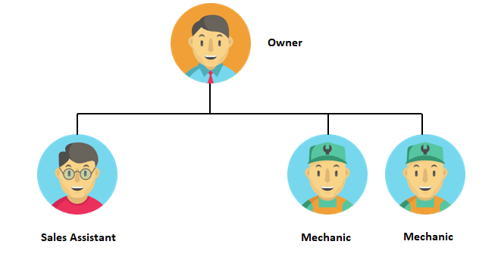

Figure 1: Jernixon Motorparts and Accessories Organizational Chart

The owner of the business is the one responsible for purchasing items from the suppliers, sales, keeping track of the items that are going in and out of the shop and other related financial activities of the business. The sales assistant advises and answers customer queries about the stock availability and details of a product. The assistant is also responsible for the selling and checking of items when the owner is on a trip to order stock from the suppliers. While the mechanics are tasked to repair motorcycles such as overhaul, change oil, tune up, wirings and set-up.

### 1.2.2 Current Business Process

The business has eleven (11) different suppliers, five (5) for parts and six (6) for accessories and they are located from different places (Urdaneta, Nueva Ecija, Basista, Caloocan, Quezon City). Before the owner goes to the supplier, a manual physical count is done by the owner and lists down the items to be bought.

The owner and the sales assistant manually records sales transactions using a pen and a notebook, including the name of the item, quantity, and the price of each item *(see attached sales list in Appendix F)*. The owner and sales assistant also checks the items physically to monitor if an item needs to be restocked. The average sales transactions per day ranges from thirty to forty (30-40). On the other hand, during weekends, holidays and upcoming motor shows the average transactions per day increases.

1. **Purchasing of Stock Directly from the supplier**

The owner does inventory count and lists down the items to be purchased. Afterwards, the owner goes to the shop of the supplier to purchase the items, and then inspects the items for any damages. After the inspection, the owner will pay the items, and after the payment, a receipt will be given by the supplier *(see attached receipt from supplier in Appendix C).*

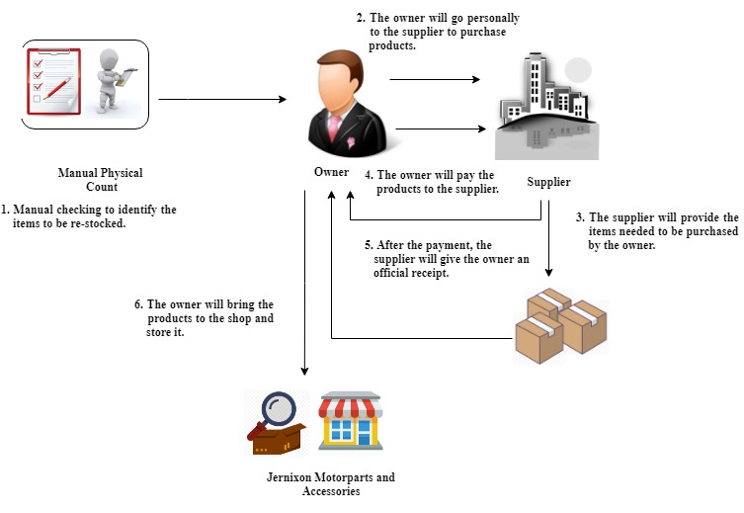

Figure 2: Purchasing of Stocks Directly from the Supplier

1. **Return**

If the items that was purchased by the owner is within the warranty period, the owner can still return it to the supplier together with the receipt as a proof of purchased. Then the supplier will change the damaged item to a new one.

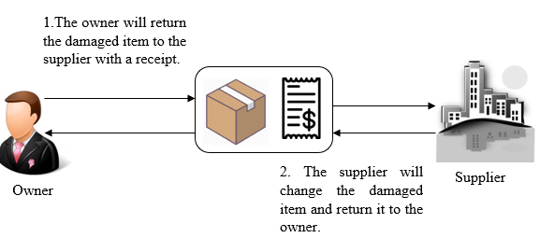

Figure 3: Return of damaged items within the warranty period

1. **Replacement**

The owner checks the products after receiving it directly from the supplier. The supplier will ensure that the products are in perfect condition, if there are damaged products then the supplier will replace it before the owner will purchase it.

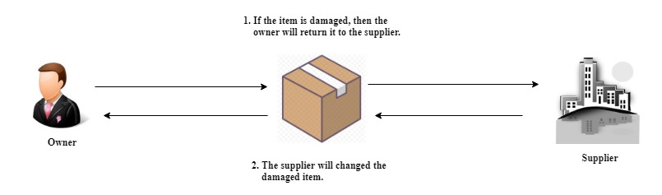

Figure 4: Replacement of damaged item before purchasing the products.

1. **Purchasing of Stocks by Email or Text Message**

The owner does inventory count and lists down the items to be purchased. Then the owner will send the list of the items needed to the supplier by email or text messages. The items will be delivered on the negotiated date. The owner will inspect the items then pay the purchased items from the supplier. Figure 3 shows the process of purchasing of stocks from the suppliers through emails or text messages (*refer to Figure 5 page 5)*.

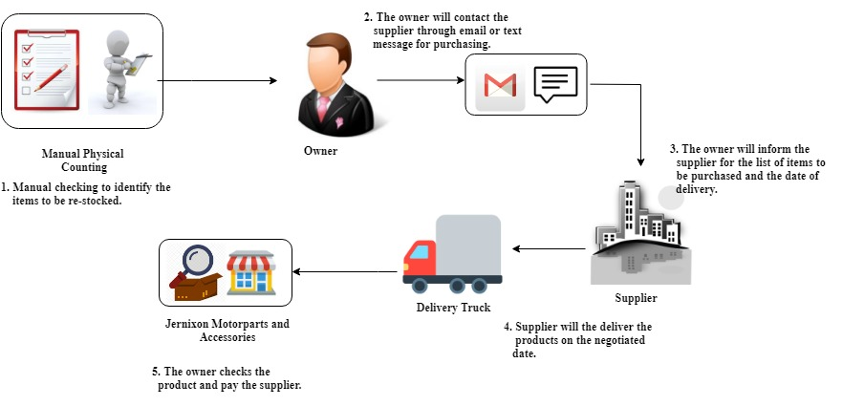

Figure 5: Purchasing of Stocks by E-mail or Text message

1. **Return**

The owner will check the products when the supplier delivers the items to the shop. The supplier will change the item upon discovering that it is damaged. If there are no items that can be exchanged, then the owner will only pay for the available items.

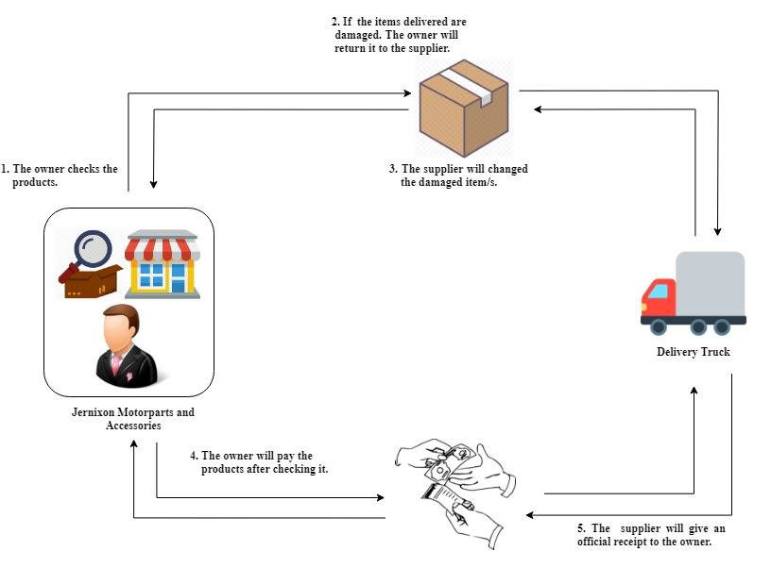

Figure 6:Purchasing of Stocks by E-mail or Text message with Return

1. **Selling of Items**

Figure 4 shows the process of selling items. First, customers inquire about the availability of a certain motor part or accessory. If an item is available, the owner will sell the items and an official receipt is issued to the customer (*see attached official receipt in Appendix D.*

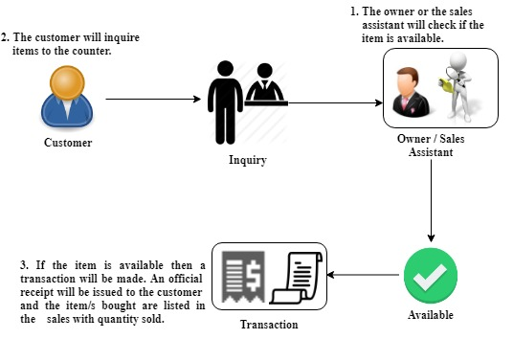

Figure 7: Selling of items

1. **Return**

The owner also gives one-week warranty to the sold items. Items with damage caused by the customer are not covered by the warranty policy. During the warranty period the shop is not accepting refunds for the item but change of item with the different items is allowed. If the item price exceeds the sold item price then the customer will pay for the exceeded amount.

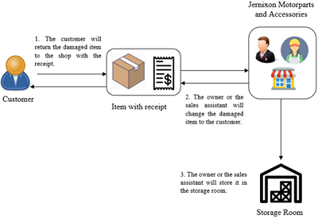

Figure 8: Return from the customer

1. **Damaged Items**

Items that are damaged due to accidents or other related disaster will be sold at purchase price or lower price to avoid loss. If no one is interested in buying the damaged product, then the item will be stored at the store room of the shop.

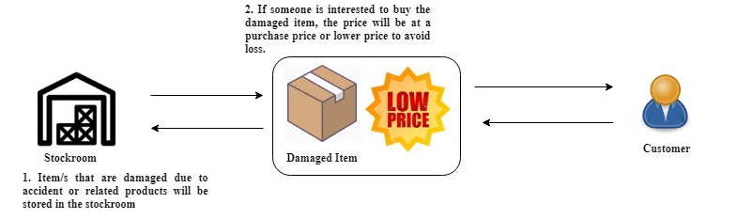

Figure 9: Damaged Items

### 1.2.3 Problems Encountered in the Current Operations

The problems that the business encountered using the existing system consist of the difficulty in keeping track of items, difficulty in knowing when to reorder products, the lack of means in knowing whether there are pilferage going on and performing physical count of inventory too often just to know the current levels of the inventory. This lack of real time access in the status of inventory levels gives the owner the problem of not knowing when to purchase an item just when it is about to be out of stock. There are chances that the items are sold out before the owner can reorder the item and this cause an interruption in the business.

The time spent in physical count can be allocated somewhere else such as accommodating customers' needs, reorder items, and buying new product. It is also a problem that the records of sales are written in paper because the paper may be destroyed in a disaster.

Problems may occur in the future because the business is growing larger and manual system may not be applicable anymore. The owner may lose track in recording their products due to the increase of sales and items. The employees and the owner may not be able to count the product correctly and sometimes the employees can forget to list down the sold items. Manual inventory cannot update the owner immediately if an item is in a critical level without going a physical count daily.

## 1.3 Statement of Objectives

The goal of the project is to develop a web-based inventory management system for the Jernixon Motorparts and Accessories. The web application will help the owner and the staff members to manage the items in the stockroom.

To fulfil the requirements of the system. The project team should be able:

* To extract the functional and non-functional requirements based on the gathered data and document review.
* To create a system design and software design based from the functional and non-functional requirements.
* To develop and test the web application with the appropriate tools and technologies.
* To create a deployment plan and train the eventual users of the inventory management system for the Jernixon Motorparts.

## 1.4 Scope of the Project

The scope of the project is to develop a web-based inventory system for Jernixon Motorparts and Accessories. In order to achieve the objectives of the project, the project team will work first on conducting an interview and document to fully understand the business process and to gather and analyze the requirements needed for the development of the project. The next step is to create mockups and diagrams to illustrate the graphical representations of the proposed project. Then design the system architecture and then eventually apply the different tools and technologies in development, and testing. The group will also conduct a scheduled meeting with the owner for feedbacks and verification after we perform testing and simulation of the two modules. Another meeting will be conducted for the deployment of the system and training of the user on how to use the web application.

## 1.5 Significance of Study

With the rapid development and change of technology, many businesses and organizations are shifting from manual process to automation. The project team will develop a system that will help Jernixon Motorparts and Accessories in such a way that it makes the tracking of inventory level of items a lot easier, reduces frequent physical count, monitors the remaining stocks for each item, and generates reports within a given timeframe to help the owner decide on how to run the business more appropriately particularly on managing the inventory.

# Chapter 2: Methodology

This chapter will discuss the Software Development Life Cycle (SDLC) that the project team will follow in the development of the project and explain each steps of the model and relate it to the objectives that were identified in chapter 1.

The project team will follow the waterfall model for the development of the system. The flow of the waterfall model is that the development proceeds from one phase to the next phase in a sequential manner and in this model the project team will only proceed to the next phase if the previous phase is already completed and approved. Figure 4 shows the illustration of the development model.

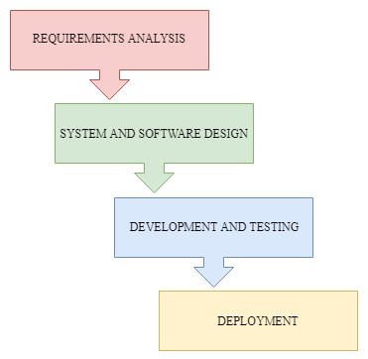

Figure 10: Waterfall Model

## 2.1 Requirements Gathering and Analysis

The group interviewed the owner of Jernixon Motorparts *(see transcript of interviews in Appendix A)* and took down some notes that will help the group to better understand the current process and transactions of the business. The transcript of interview contains the details on how the owner ordered supplies, when do they order, how many products do they have and others.

The group also took some pictures of the forms, names of products and also the prices of each products *(refer to Appendix E)*. The project team reviewed all the gathered information in order to identify the functional and non-functional requirements in the development of the web-based application. The functional requirement pertains to the functionality of the component in the system. Non-functional is about the characteristics of the system.

## 2.2 System and Software Design

### 2.2.1 System Design

For the system design of the application the group will use Data Flow Diagram (DFD) to easily understand the process and transaction of the business, Data Dictionary that will define the terms used in the DFD, use case to show the interaction of the users and the system, System architecture, Entity Relationship Diagram (ERD) and Relational Database Scheme to illustrate the graphical representations and logical view of the database. This will help the project team in developing the database for the inventory system.

### 2.2.2 Software Design

After gathering and analyzing the data from the current business process, the project team will be using mock-ups to create designs for the application based on the requirements that were identified. Some open source and commercial software were also considered and the best features will be adopted to further enhance the system. Using mock-ups, it is easy for the group to design the user interface of the application that can immediately be seen by the owner for approval or changes in the design.

## 2.3 Development of the System

### 2.3.1 Development

Identifying the different open source tools that will be used in creating the web-based application. Example of these are version control systems, web development tools, source code editors, and project management tools. In development phase, the coding and integration of the tools and technologies will start.

Version control systems are needed in the project because it helps the group to coordinate in terms of tracking the changes, managing and storing the source code online. Web developments tools is used to view the web application. Source code editors is where the programmers create and edit the codes.

### 2.3.2 Timetable and Roles of members

In order to speed up our work and manage our time in making the system, the project team made a timetable to make sure that there is no time wasted in a day. The project team allocated the task individually in our project team, so that our work will be finished faster.

### 2.3.3 System Testing

While developing the system, the project team will test the application to determine the errors in the program. The project team will perform a simulation of the two modules, and an error checking. Functional testing will be used in the web application to ensure that the operation of the system is within the requirements of the project.

## 2.4 Deployment of the System

After the testing and development, the system will be presented to the owner and the owner will evaluate the application. If the owner is satisfied, then the web application will be installed with necessary requirements. After the installation, the project team will orient the owner and the sales assistant regarding ~~about~~ the system. // hindi ba same ung about sa regard?

# 

# Chapter 3: Outcomes and Results

This chapter will be the discussion of the outcomes and results of the project by answering the objectives identified in chapter 1 and by following the methodology that was discussed in chapter 2.

## 3.1 Analysis

Based on the conducted interview we are able to gather a transcript of the interviews shown in Attachments/Appendix. The project team also determined the functional and non-functional requirements of the proposed system. Table 1shows the functional requirement for each module, these components are inputs, outputs, behaviour and specifies what the system should do. Table 2 is the non-functional requirements specifying the system’s quality and it describes how the system should work.

### 3.1.1 Functional Requirements

The functional requirements define a system or a function of a system or its components. It is defined as the set of inputs, outputs and behavior of the system. Table 1 show the functional requirements for the admin module and sales assistant module.

|  |  |
| --- | --- |
| **Functional Requirements** | **Description** |
| Log in | Allows the owner and the assistant to enter user credentials in order to access the system. |
| Reports | Generates an excel or pdf file that contains the products and its quantities, it also allows the owner to view the list of items that needs to be restocked. The report can only be viewed by the owner. |
| Viewing of products | A list of all products can be viewed by the owner and the assistant. |
| Notifications | Ensure that the owner know what items are needed to restock. The notification is also contain stock adjustment and return. |
| Search | Allows the owner and the sales assistant to find items easily and fast. |
| Sales | Where the owner and sales assistant can sell the items and search item. The sales assistant can't see the wholesale price of an item. |
| History | Ensure that the owner can keep track of all the old transactions for every product. |
| Add, update product information | Allows the owner to add and update product information of every items in the inventory system. |
| Returns | Allows the owner to record activities of returning defective items. |
| Purchase | Purchase is where the owner can restock the items and see the items that are restocked before. |
| Stock Adjustment | The owner and sales assistant can adjust stock. |
| Physical count | Physical count is where the owner and sales assistant will do a physical count and input the data gathered to compare if the physical inventory and system have the same item level. |

Table 1: Functional Requirements

### 3.1.2 Non-Functional Requirements

The non-functional requirements elaborate the characteristics and performance of the system and it describes how the system works. Table 2 shows the non-functional requirements.

|  |  |
| --- | --- |
| **Non-Functional Requirements** | **Description** |
| Security | The web-based application can only be viewed by the owner and sales assistant. Without the credentials, no one can view it; this ensures the security of the application. |
| Usability | The application should be user friendly. It can be easily used by the business to improve their business needs. |
| Reliability | The application should be effective enough to improve the process of the business. The owner should be able to rely on the system since it will be used for a period of time. |
| Availability | The application should always be available to the users whenever the users want to access it. |
| Accuracy | The count of the items in the inventory system should be accurate and precise to match the physical count of the inventory. |

Table 2: Non-Functional Requirements

**3.2 System and Software Design**

Different design specifications will be used in the development of the project in order for the project team to visualize the proposed system.

### 3.2.1 System Design

The process of defining the entity relationship diagram (ERD), relational database scheme, data flow diagram (DFD), data dictionary, use case, and system architecture.

**A. Entity Relationship Diagram (ERD)**

Entity Relationship Diagram show the table and columns that will be created in the database and the relationship of each tables together with its attributes. ERD helps the user to understand what data can be stored in each table and attributes.

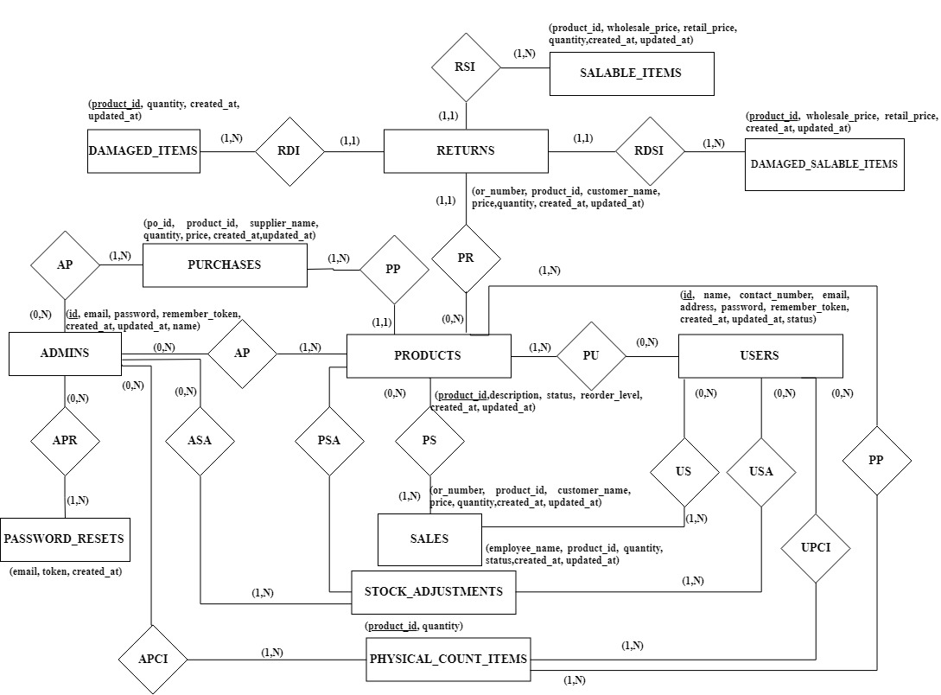

Figure 11: Entity Relationship Diagram

**B. Relational Database Scheme**

ADMINS (id, email, password, remember_token, created_at, updated_at, name)

DAMAGED_ITEMS (product_id, quantity, created_at, updated_at)

FK product_id References PRODUCTS Nulls Not Allowed

Update Cascade Delete Cascade

DAMAGED_SALABLE_ITEMS (product_id, wholesale_price, retail_price, quantity, created_at, updated_at)

FK product_id References PRODUCTS Nulls Not Allowed

Update Cascade Delete Cascade

LOST_ITEMS (product_id, quantity, created_at, updated_at)

MIGRATIONS (id, migration, batch)

PASSWORD_RESETS (email, token, created_at)

PHYSICAL_COUNT (status, date)

FK product_id References PRODUCTS Nulls Not Allowed

Update Cascade Delete Cascade

PHYSICAL_COUNT_ITEMS (product_id, quantity)

FK product_id References PRODUCTS Nulls Not Allowed

Update Cascade Delete Cascade

PRODUCTS (product_id, description, status, reorder_level, created_at, updated_at)

PURCHASES (po_id, product_id, supplier_name, quantity, price, created_at, updated_at)

FK product_id References PRODUCTS Nulls Not Allowed

Update Restrict Delete Restrict

RETURNS (or_number, product_id, customer_name, price, quantity, created_at, updated_at)

FK product_id References PRODUCTS Nulls Not Allowed

Update Cascade Delete Cascade

SALABLE_ITEMS (product_id, wholesale_price, retail_price, quantity, created_at, updated_at)

FK product_id References PRODUCTS Nulls Not Allowed

Update Cascade Delete Cascade

SALES (or_number, product_id, customer_name, price, quantity, created_at, updated_at)

FK product_id References PRODUCTS Nulls Not Allowed

Update Cascade Delete Cascade

STOCK_ADJUSTMENTS (employee_name, product_id, quantity, status, created_at, updated_at)

FK product_id References PRODUCTS Nulls Not Allowed

Update Cascade Delete Cascade

USERS (id, name, contact_number, email, address, password, remember_token, created_at, updated_at, status)

**C. Data Flow Diagram (DFD)**

The team created the data flow diagram to easily understand the current business process. To know where the data or information will be coming from and to know what data are being stored (*refer to Figure 12 Data Flow Diagram*).

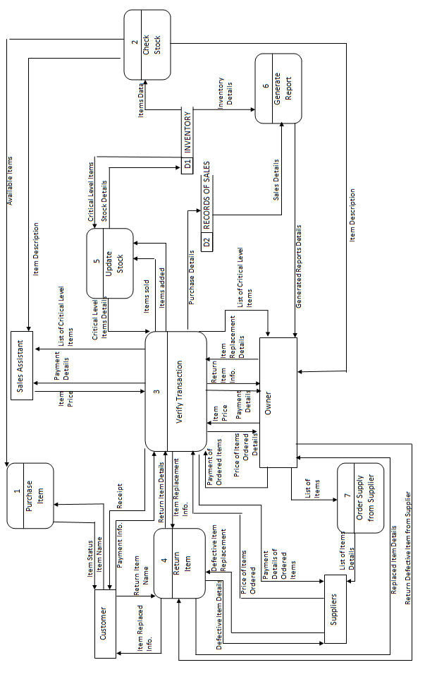

Figure 12: Data Flow Diagram

**D. Data Dictionary**

Table 3 shows the Data Dictionary, wherein the terms identified in the DFD were defined. The data dictionary also contains the information about the relationship of data, the type of data and others, that will help the user to better understand the information what data or information are being passed in the DFD.

Table 3: Data dictionary

|  |  |  |
| --- | --- | --- |
| A | | |
| Address | = | Characters |
| Age | = | Numeric |
| Amount Paid | = | Numeric |
| Available Items | = | Item Name+ Price+ Brand+ Quantity in stock |
| B | | |
| Brand | = | Characters |
| boolean | = | { [yes | no] | [true | false] } |
| C | | |
| Change | = | Boolean |
| Change in Stock | = | { Increase| Decrease} |
| Characters | = | { [a..z] | [A..Z] | , . ? ! @ } + numeric |
| Contact Info. | = | Numeric |
| Critical Level Item | = | Item Name+ Brand+ Quantity in Stock |
| Cust_id | = | Numeric |
| Customer | = | cust_id+ Name+ Contact Info+ Address+email |
| Customer Quantity | = | Numeric |
| D | | |
| Date | = | Year+Month Day |
| Date In | = | Date |
| Date Out | = | Date |
| Date of Birth | = | Date |
| Date of Purchase | = | Date |
| Date of Report | = | Date |
| Day | = | [00...31] |
| Defective Items Details | = | Item Name+ Brand +Reason + Date of Purchased |
| Defective Items Replacement | = | Item Name + Brand |
| E | | |
| Email | = | Characters |
| G | | |
| Generate Reports | = | RECORDS OF SALES + INVENTORY |
| Generated Reports | = | RECORDS OF SALES + INVENTORY + Date of Report |
| I | | |
| INVENTORY | = | prod_id + Item Name + Date In + Date Out + Quantity in Stock + Status + price + Net Weight+ Sup_id |
| Item Data | = | INVENTORY |
| Item Description | = | Item Name+Type of Items+ Brand+ Quantity in Stock+ Net Weight |
| Item Replacement Info. | = | Item Name + Brand+ Quantity + Change+Date |
| Item Name | = | Characters |
| Item Price | = | Item Name + Price |
| Item Replacement | = | Item Name + Brand+ Quantity + Change |
| Item Replacement Details | = | Item Name +Brand+ Quantity+ Change |
| Item Sold | = | Item Name + Brand+ Customer Quantity |
| Items Status | = | Item Name+ Brand + Status |
| L | | |
| List of Critical Level Items | = | Critical Level items+ Date |
| List of Items | = | Item Name + Brand + Quantity |
| List of Items Details | = | List of Items +Date |
| M | | |
| Month | = | { [January..December] | [01..12] } |
| N | | |
| Name | = | Characters |
| Net Weight | = | Numeric |
| Numeric | = | [0..9] |
| O | | |
| owner_id | = | Numeric |
| Owner | = | owner_id+ Name+ Contact Info+ Address+ Email+ Age+ Date of birth |
| P | | |
| Payment Details | = | Item Name +Customer Quantity + Amount Paid + Brand |
| Payment Info. | = | Amount Paid +Item Name+ Brand + Customer Quantity |
| Payment of Ordered Items | = | Item Name+ Brand +Price +Amount Paid+ Date |
| Payment of Ordered Items Details | = | Price of Ordered Items+ Amount Paid+ Date |
| Price | = | Numeric |
| Price of Ordered Items | = | List of Items + Price |
| Price of Ordered Items Details | = | Item Name + Quantity +Price |
| Prod_id | = | Numeric |
| Purchase Details | = | Item Name +Customer Quantity + Amount Paid + Brand+ Customer Name+ Date of Purchase |
| Q | | |
| Quantity in stock | = | Numeric |
| R | | |
| Reason | = | Characters |
| RECORD OF SALES | = | Item Name + Date+ Price + Customer |
| Receipt | = | Date of Purchase+ Item Price+ Brand + Customer Quantity + Amount Paid |
| Replaced Item Details | = | Item Name + Brand + Date |
| Return Defective Item from Supplier | = | Item Name+ Brand+ Quantity+ Reason |
| Return Item Info. | = | Item Name + Date of Purchase+ Reason + Customer Name |
| Return Item Name | = | Characters |
| Return Item Name | = | Return Item Name + Reason |
| S |  |  |
| SA_id | = | Numeric |
| Sales Assistant | = | SA_id+ Name+ Contact Info+ Address+ Email+ Age+ Date of birth |
| Sales Details | = | Records of Sales |
| Status | = | boolean |
| Stock Details | = | Item Name+ Brand + Quantity+ Date + Change in Stock |
| Sup_id | = | Characters |
| Suppliers | = | Sup_id+ Name + Contact Info+ Address + Email |
| T |  |  |
| Type of Item | = | Characters |
| Y |  |  |
| Year | = | Numeric |

**E. Use Case**

Figure 13 shows the use case diagram for the business that shows the interaction between the users and the system wherein the admin can access all the functionalities in the system such as adding of items, view history, view transaction and generate report while for the sales assistant he/she can only access the login, notification, view items, search items, and payments.

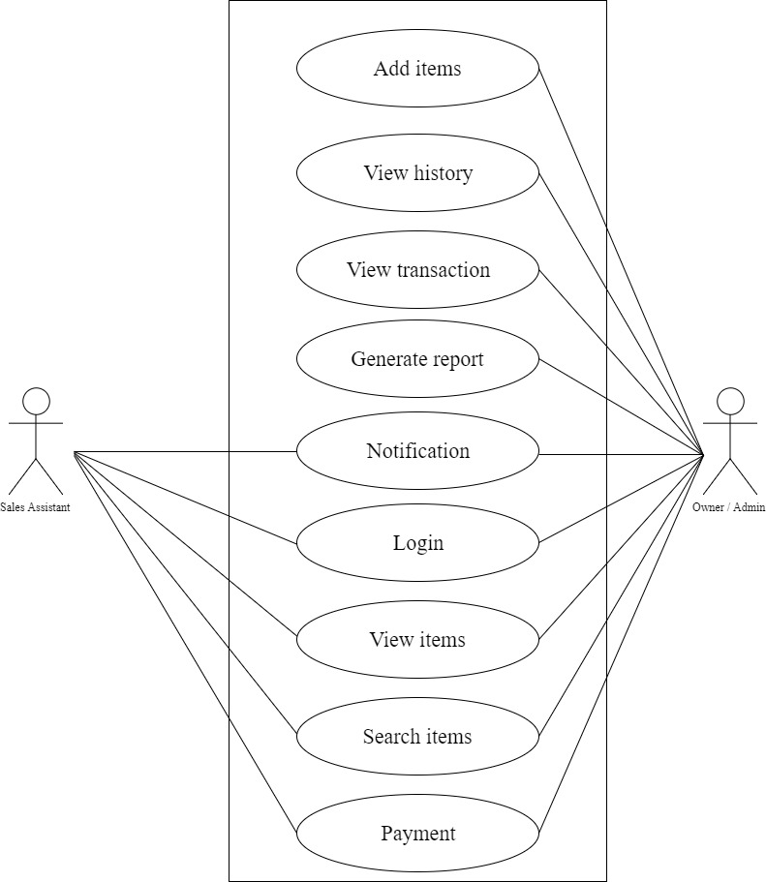

Figure 13: Use Case Diagram

**F. System Architecture**

Figure 14 shows the system architecture of the Jernixon Motorparts and Accessories. Figure 14 is about how the system interacting with the user with the use of applications and devices.

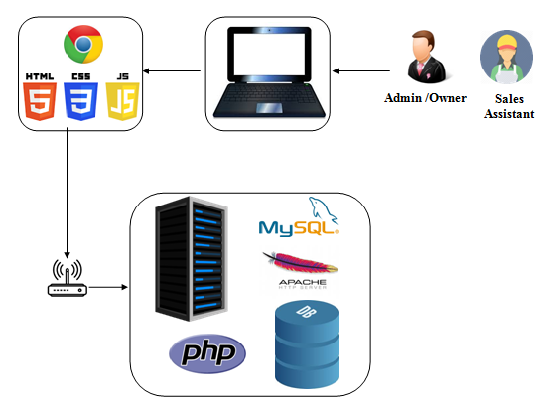

Figure 14: System Architecture

### 3.2.2 Software Design

**A. Admin Module**

**Admin Login**

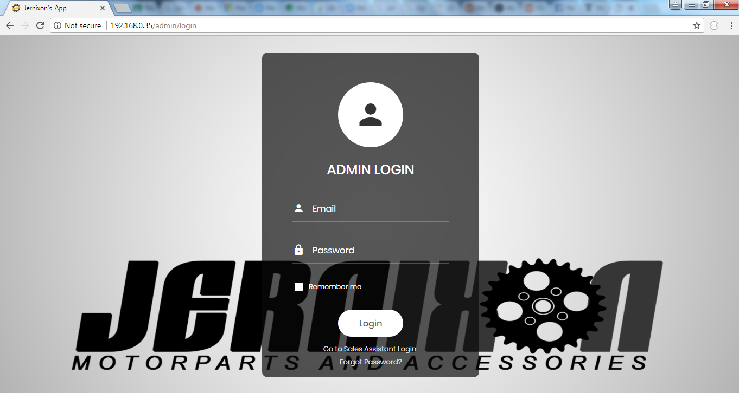In the admin’s login, the owner is required to enter the username & password then click the login button. The project team used the login because there are two modules, the admin, and the sales assistant. They have different privileges and there's a functionality that only the owner can access.

*Figure 15: Admin Login*

**Admin Dashboard 1**

In the admin dashboard, where the owner can see the summary of the business such as user, total items and numbers of re-order items.

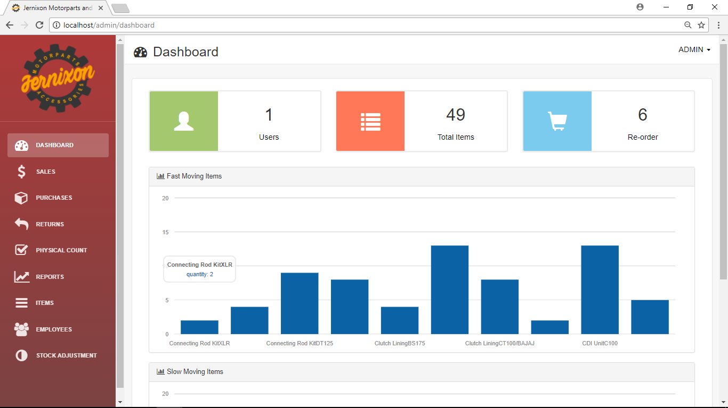

Figure 16: Admin Dashboard 1

**Admin Dashboard 2**

The owner can monitor the top 10 best-selling or fast-moving items and the slow-moving item sold.

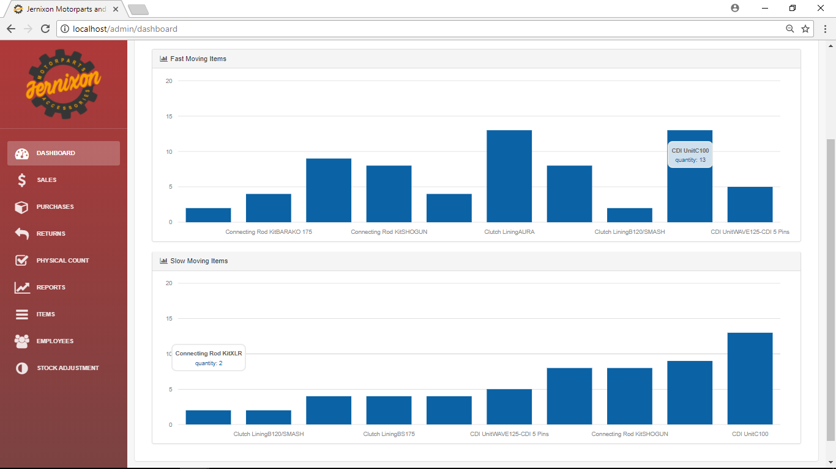

Figure 17: Admin Dashboard 2

**Admin Reports**

In the admin report, the owner can see the items sold to the customer, the quantity, original receipt number (OR number), customer name, purchased price, and the date that the transaction was done. The owner can export the details shown in this page.

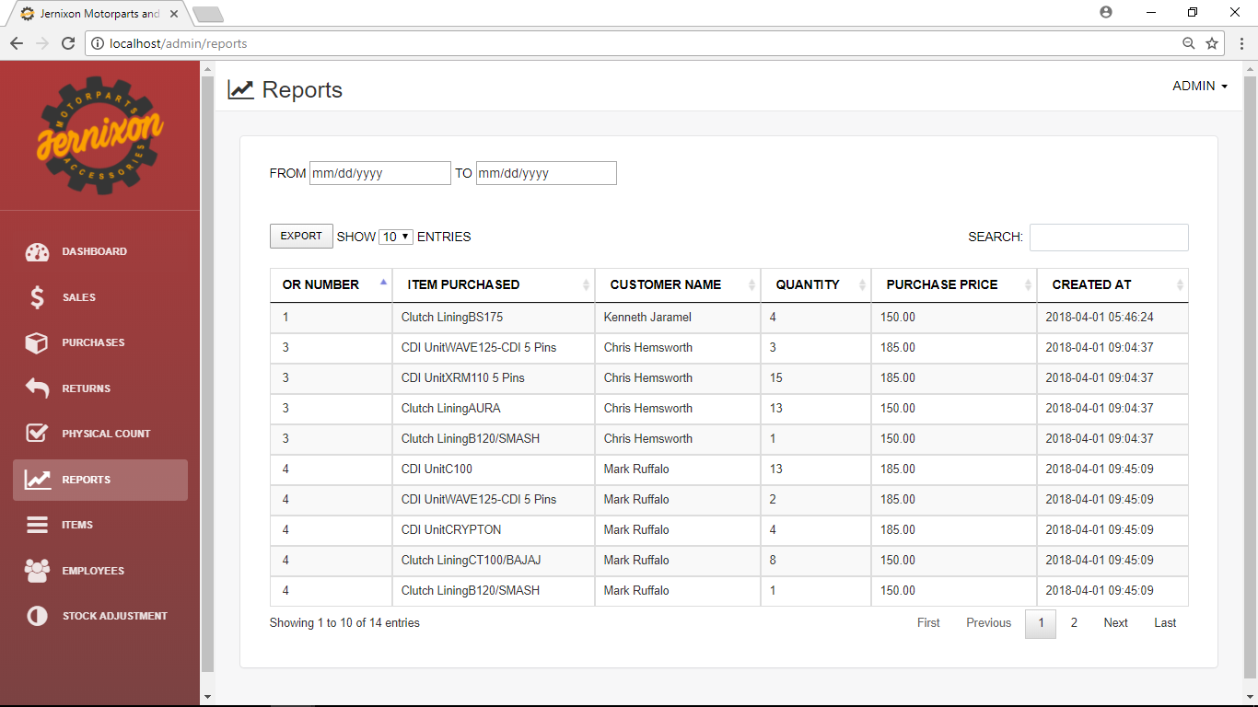

Figure 18: Admin Reports

**Admin Notification**

In the admin’s notification, the owner will be notified if a certain item is already low on stock and when an item was adjusted.

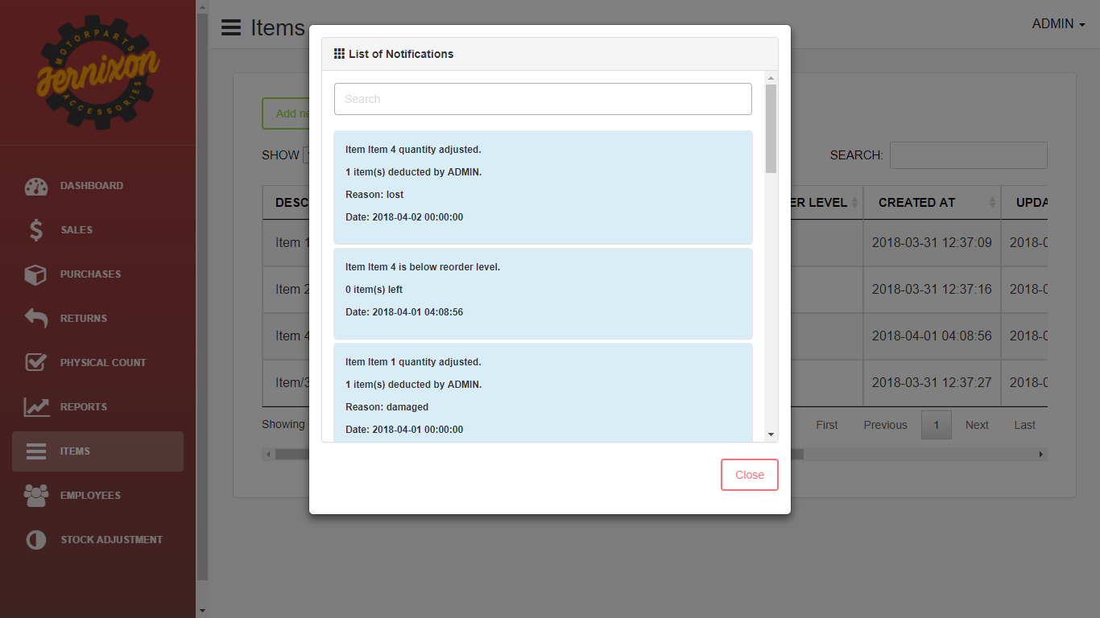

Figure 19: Admin Notification

**Admin Items - 1**

In the admin items - 1, is where all items are listed. The details of items are also shown such as quantity, description, purchase price, selling price, and re-order level.

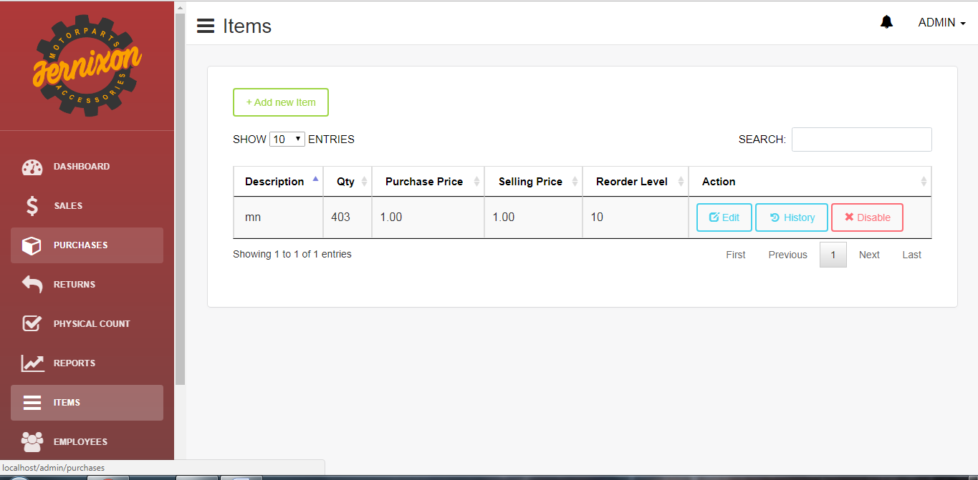

Figure 20: Admin Items - 1

**Admin Items – 2**

The owner can edit the details of the items, view the history of the items and disable or enable an item.



Figure 21: Admin Items - 2

**Admin Items - 3**

In the admin items - 3, the owner can add new item. The details of adding a new item are description and the re-order level. The owner can choose either to save or cancel the adding of the item.

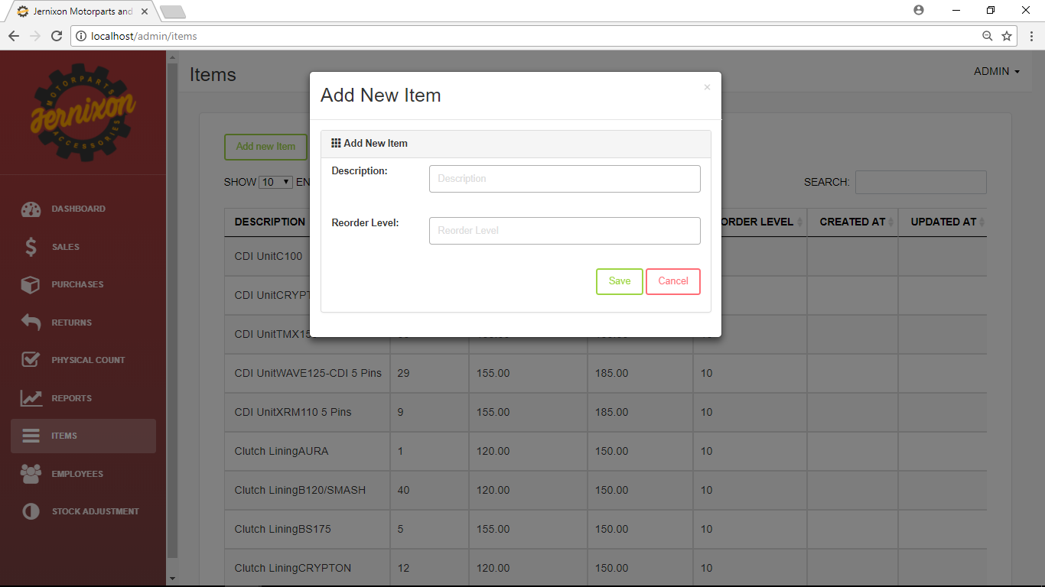

Figure 22: Admin Items - 3

**Admin Items – 4**

In the admin item - 4, the owner can edit the information about the item. The details that can be edited are the description, selling price and re-order level.

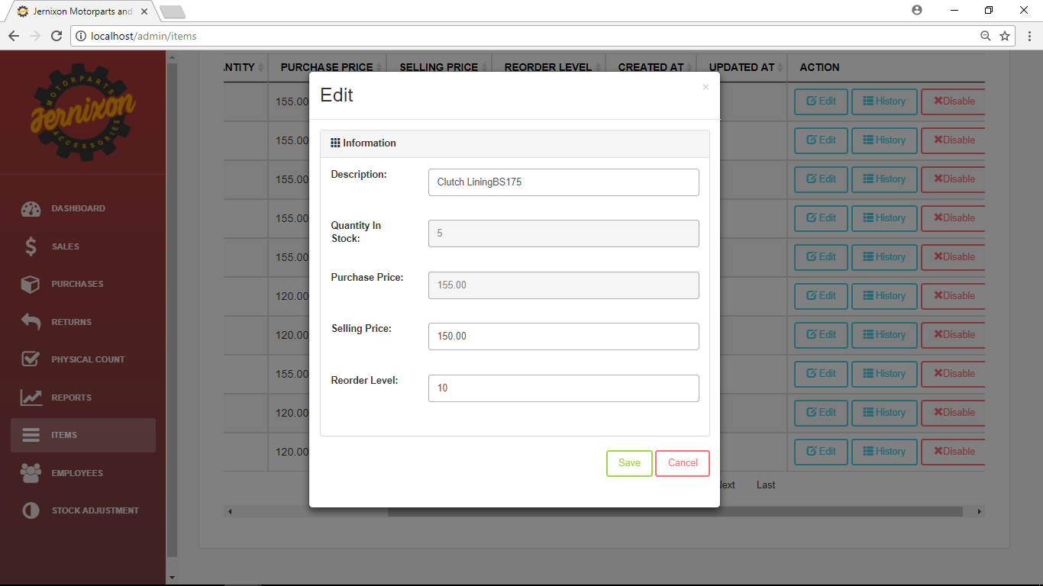

Figure 23: Admin Items - 4

**Admin Items – 5**

In the admin items - 5, the owner can see the history of the item. The red list represents the deducted items while the green list represents the added items. The items history contains details such as number of items that was bought or deducted, date, supplier name, customer name, the user who performed the stock adjustment, amount and the reasons like lost, damaged or purchased.

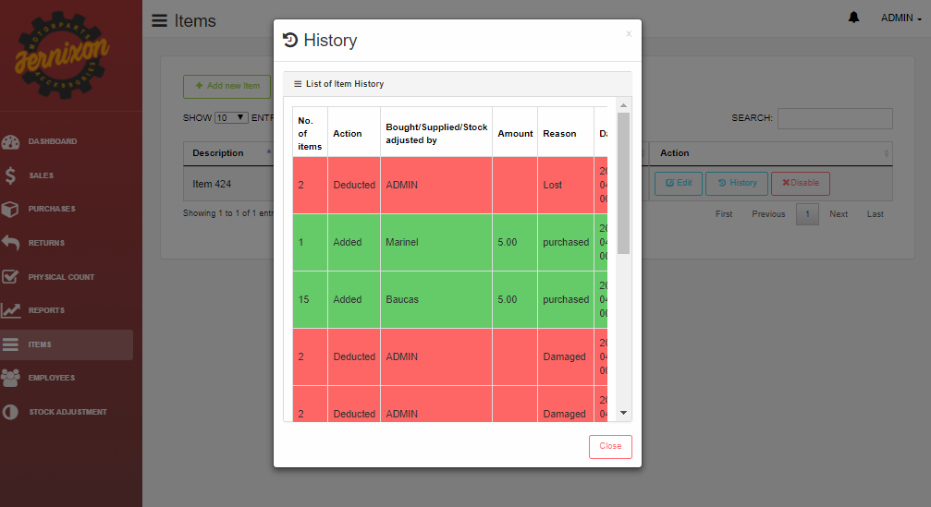

Figure 24: Admin Items - 5

**Admin Account Management - 1**

In the admin account management - 1, the admin will be the one to give an account to each sales assistant. In Figure 25, the owner can see the details of the employees. The owner can reset the password of the employee and also deactivate or activate the account their accounts.

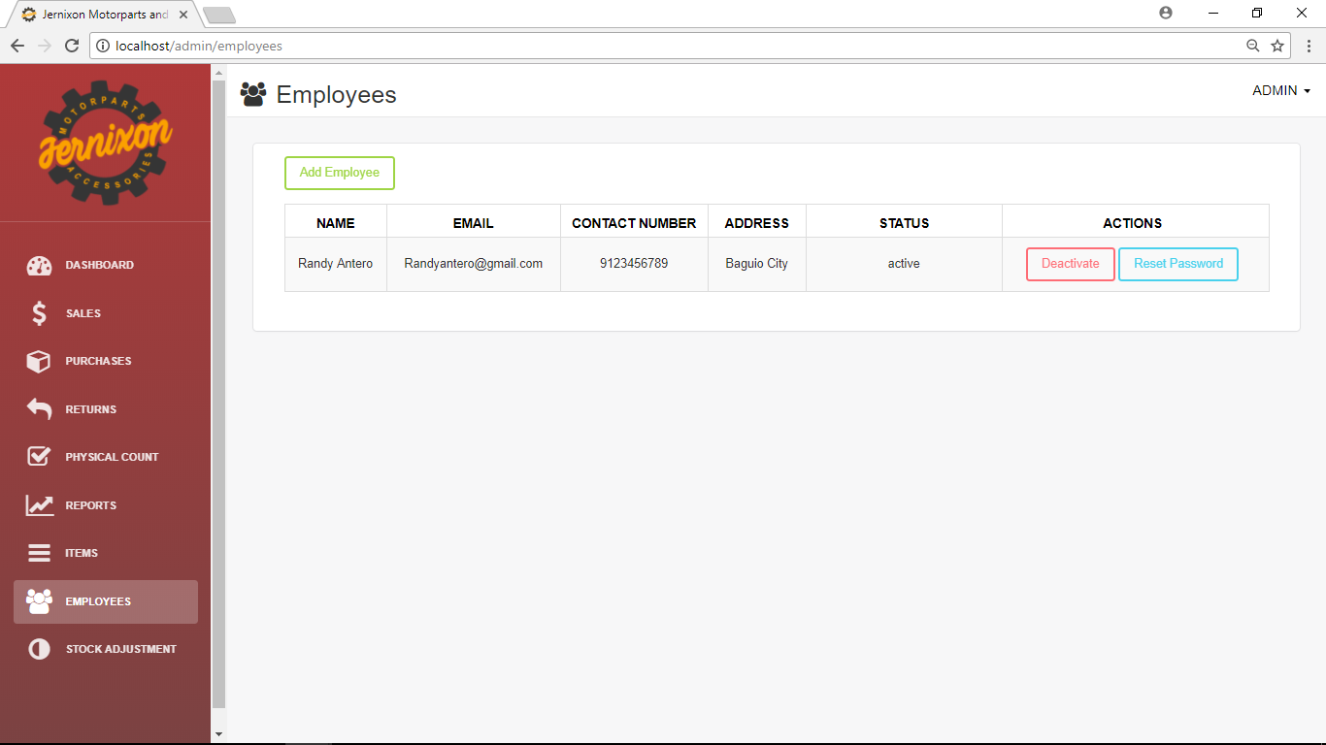Figure 25: Admin Account Management 1

**Admin Account Management - 2**

The owner will first click the add user button and then the owner can fill up the following details (name, email, contact number and address).

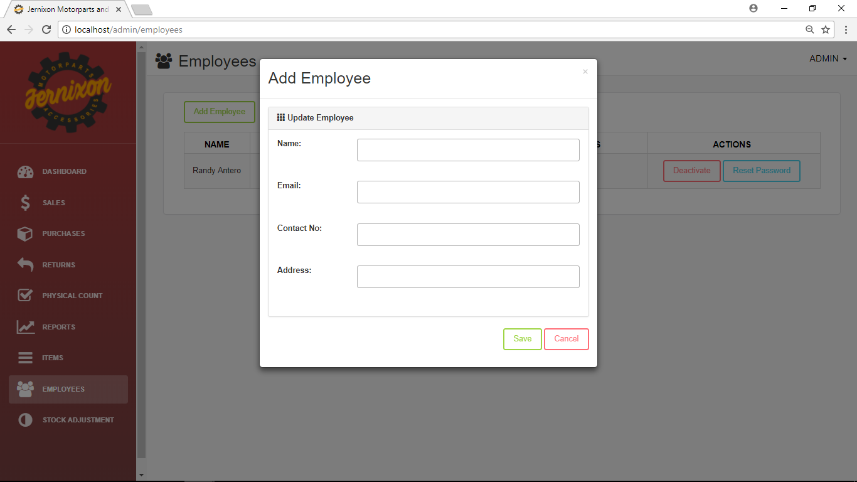

Figure 26: Admin Account Management 2

**Admin Sales - 1**

In admin sales 1, the owner can search and view the detail of items. The add or plus button is used when a customer want to buy products from the shop

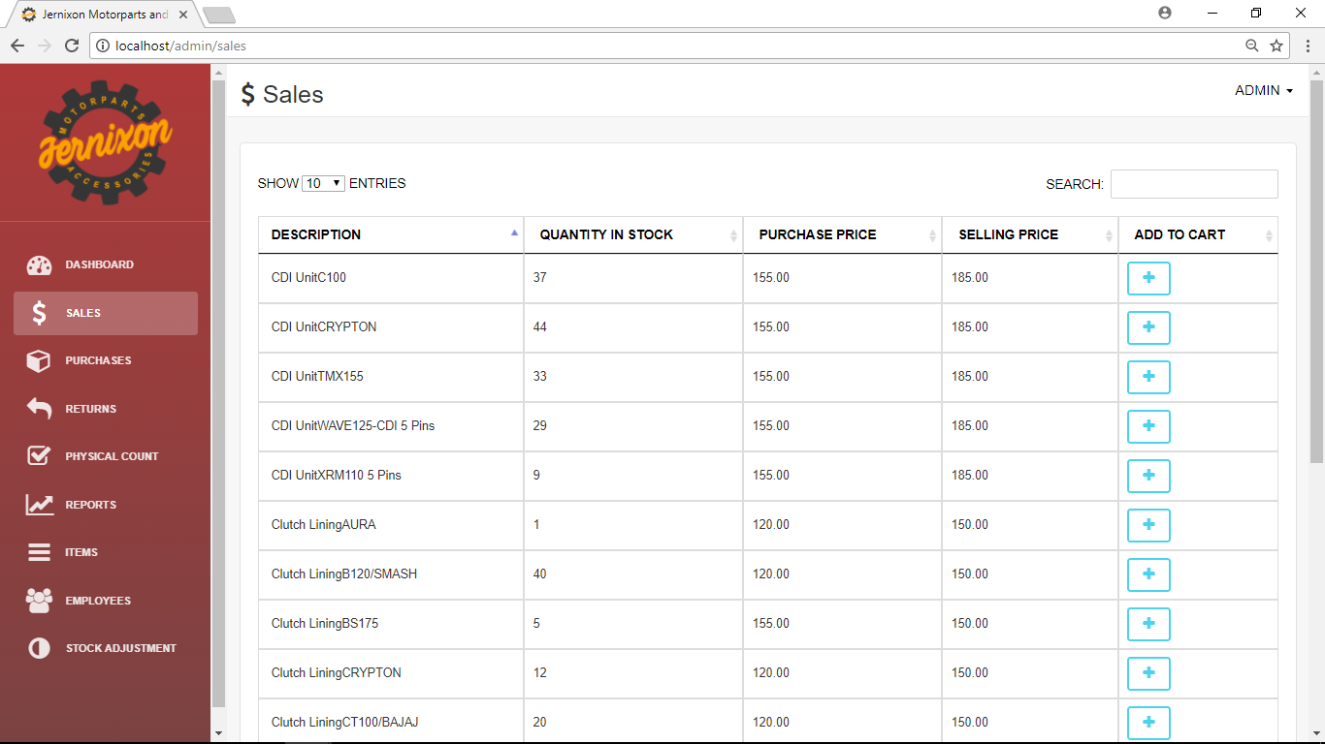

Figure 27: Admin Sales 1

**Admin Sales - 2**

Admin sales 2 shows the items that the customer will buy. The plus button will add the item to the customers cart. The details that can be seen in the customers cart are the items, price, quantity purchase, sales price, and the total sales or total price of all the items in the cart.

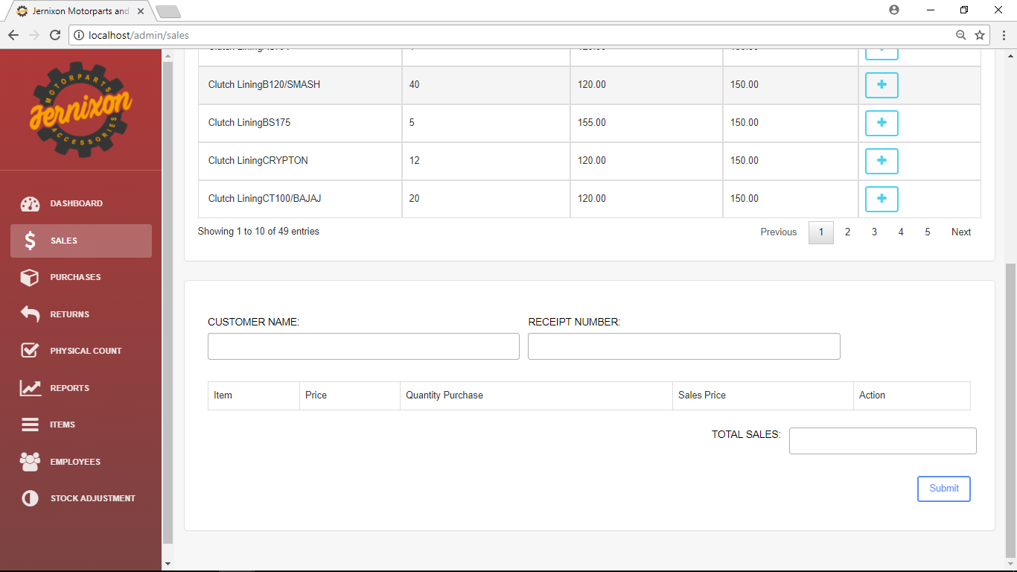

Figure 28: Admin Sales 2

**Purchases 1**

Purchase is where all the items purchased from specific suppliers are recorded. P.O. id is the purchase order id and date create is when the purchase was made. The view shows the details of each purchase.

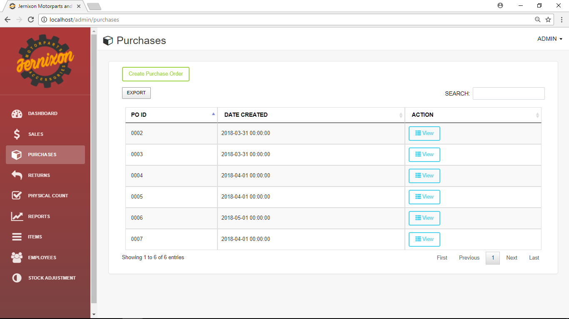

Figure 29: Purchases 1

**Purchases 2**

Figure 30 is where purchase is created. The owner will need to fill up the official receipt number, supplier and add items by searching in the input box in order to make a purchase.

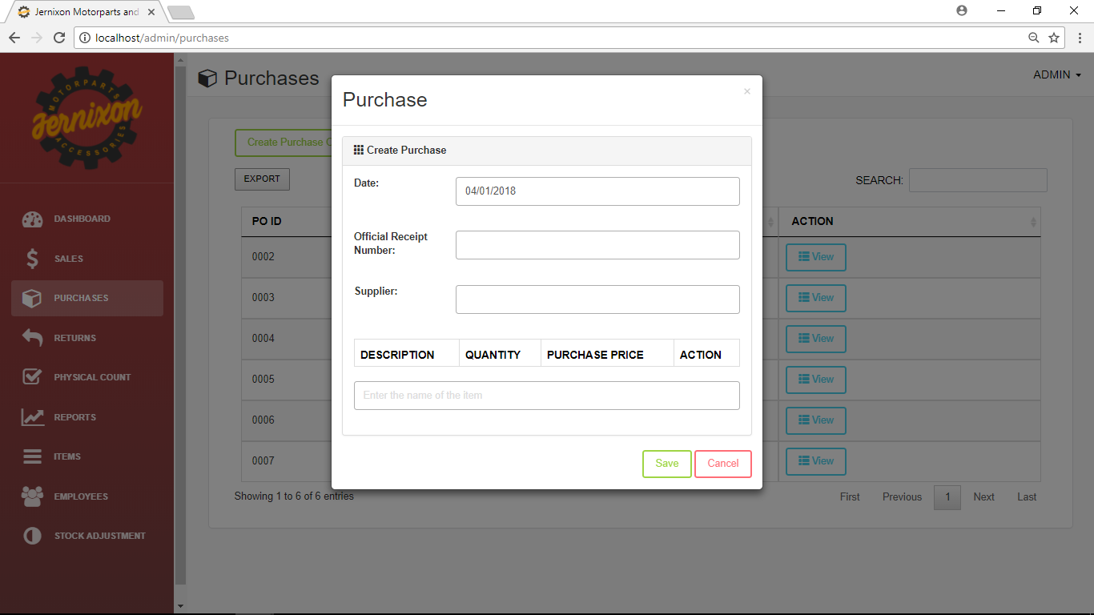

Figure 30: Purchase 2

**Admin Returns 1**

Admin Returns 1 show the information about the items that are return. The view gives more details about the return of an item.

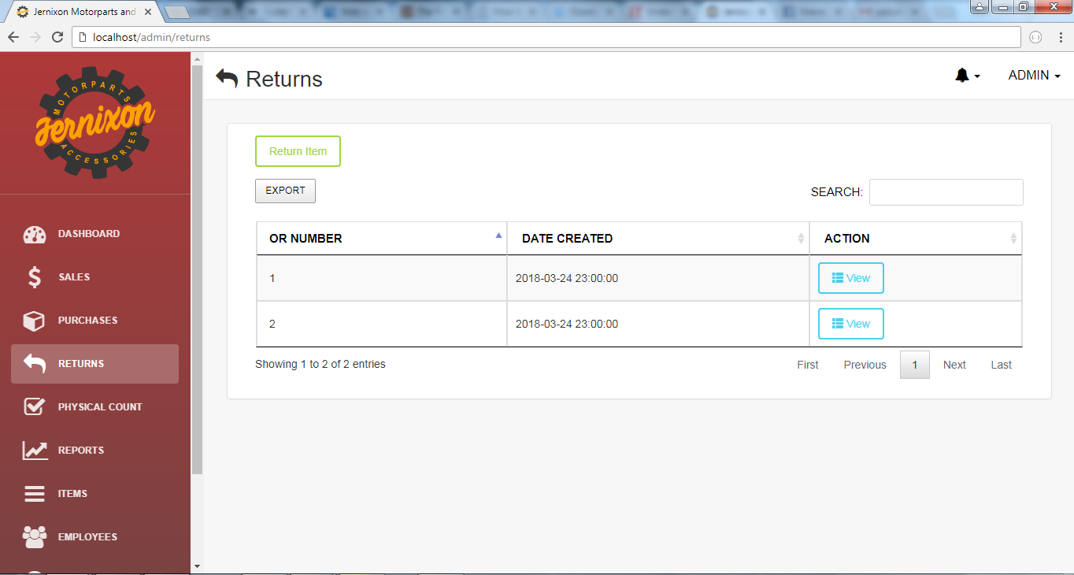

Figure 31: Admin Returns 1

**Admin Returns 2**

Figure 32 shows the information needed to be fill up by the owner in order to record the return to the system.

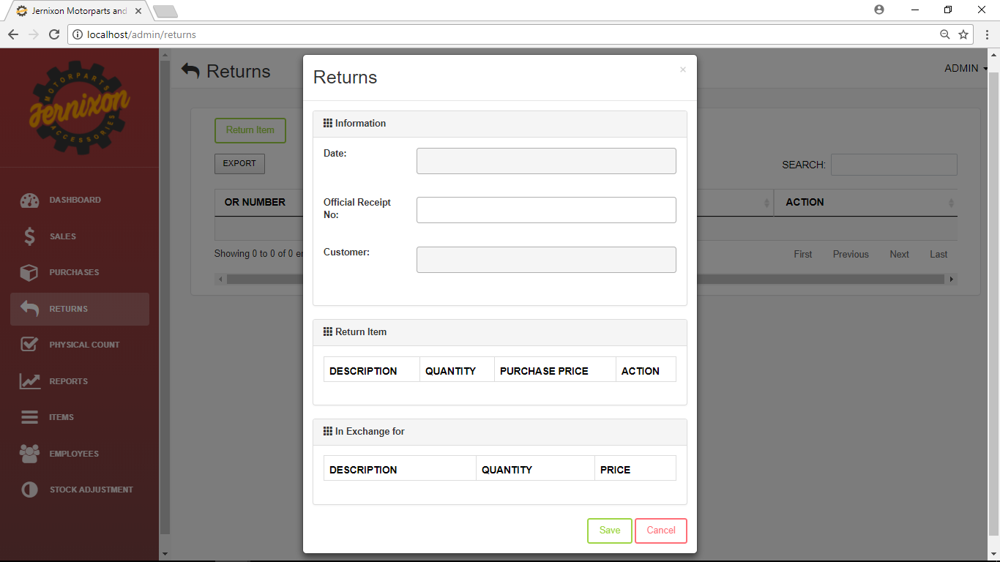

Figure 32: Admin Returns 2

**Admin Returns 3**

Figure 33 is the continuation of admin return 2. Official receipt number is needed to be fill up by the owner in order to view the details of the item s that is needed to be return.

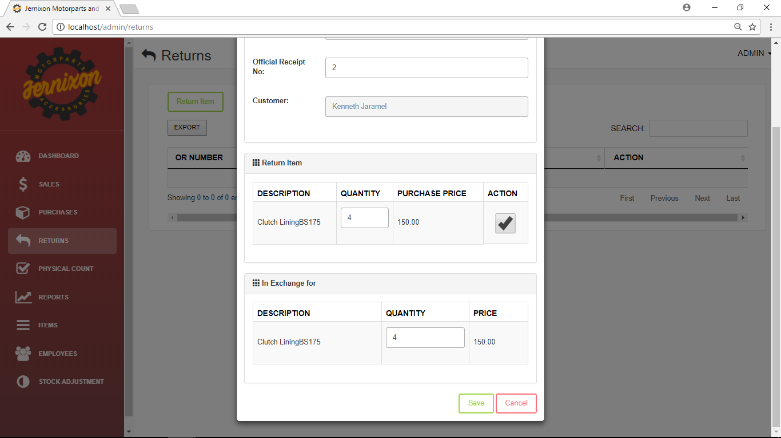

Figure 33: Admin Returns 3

**Admin Returns 4**

Admin returns 4 show the details of a returned item.

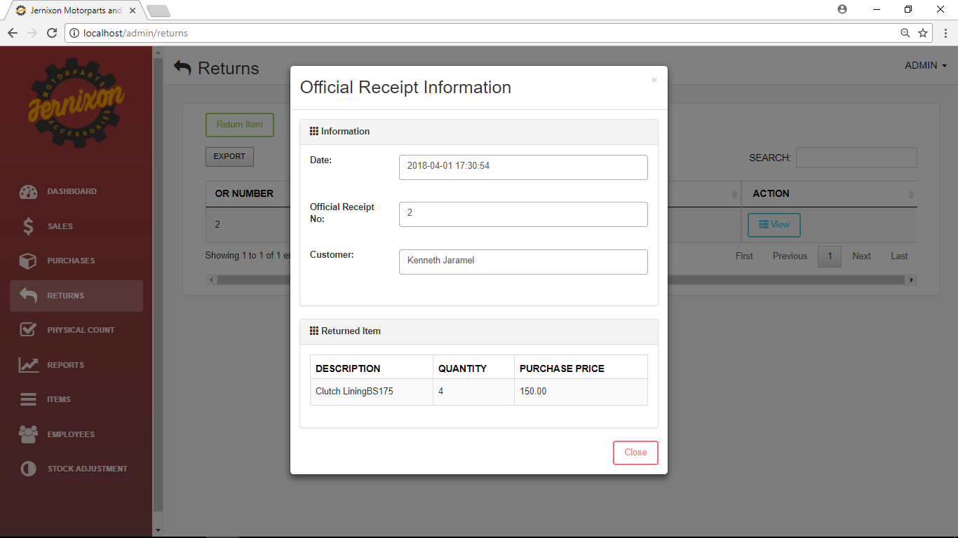

Figure 34: Admin Returns 4

**Admin Physical Count 1**

Where the owner starts physical count to see if the system count is the same with the physical count conducted by the sales assistant.

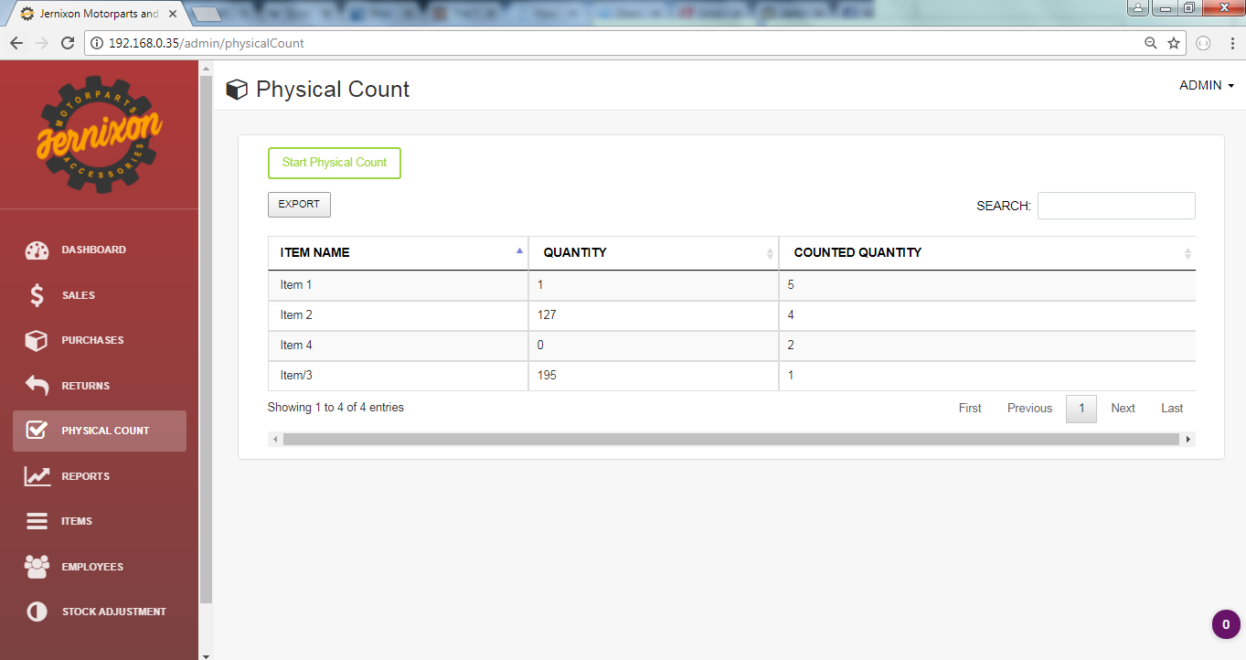

Figure 35:Admin Physical Count 1

**Admin Physical Count 2**

The owner can start a physical count and when the physical count is ongoing, some function of the sales assistant will be disabled.

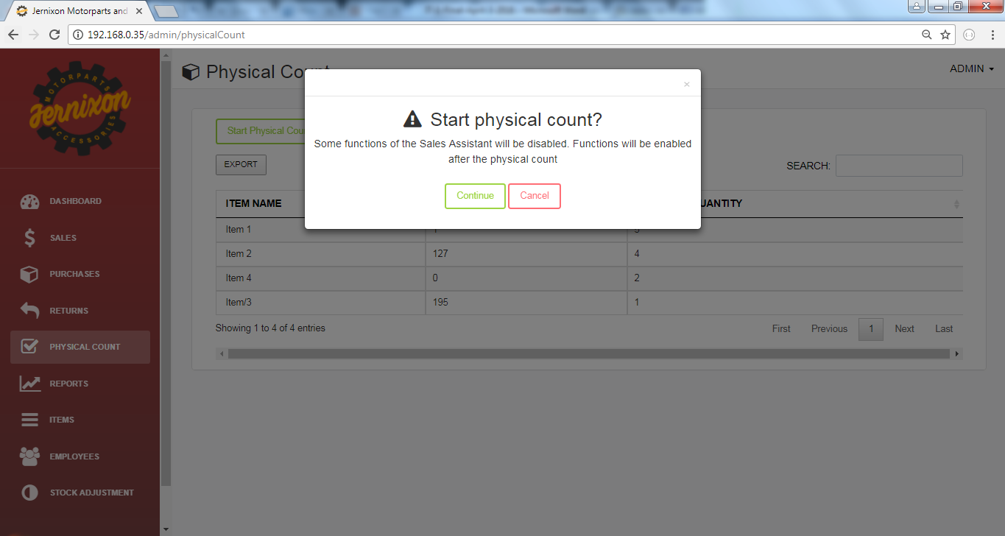

Figure 36:Admin Physical Count 2

**Admin Stock Adjustment 1**

In the admin stock adjustment, the owner can see the user name, item name, quantity, status and date.

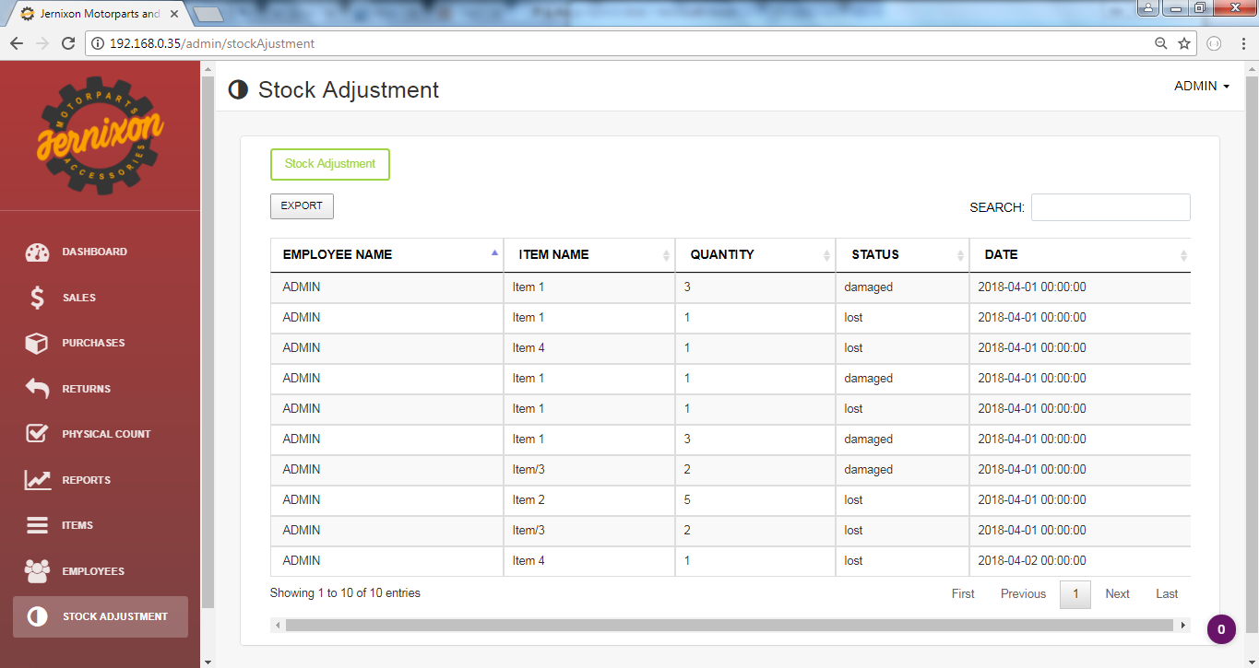

Figure 37: Admin Stock Adjustment 1

**Admin Stock Adjustment 2**

Figure 38 shows the modal or a pop-up window where the owner fills up the necessary information for the stock adjustment.

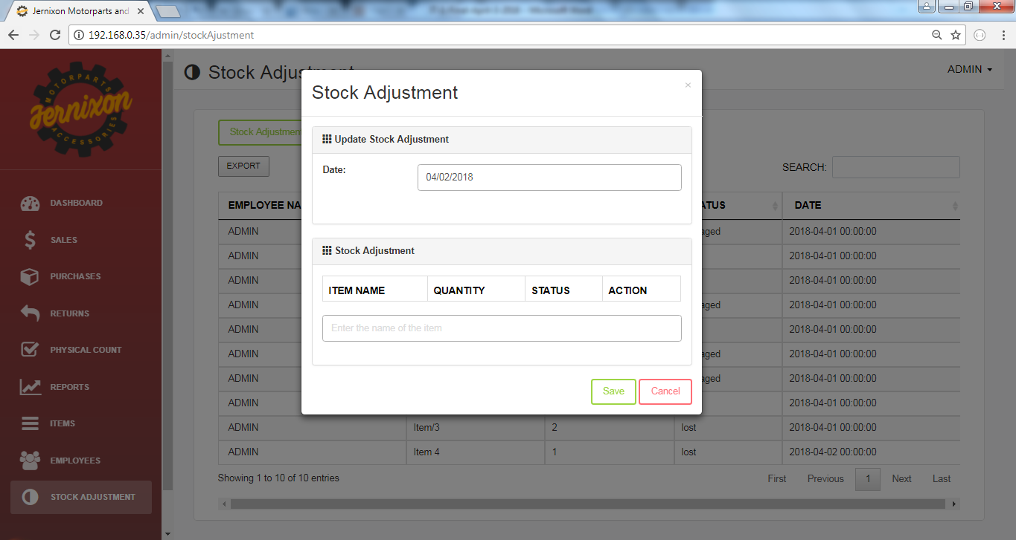

Figure 38:Admin Stock Adjustment 2

**B. Sales Assistant Module**

**Sales Assistant Login**

In the sales assistant’s login, the assistant is required to enter username and password then click the login button.

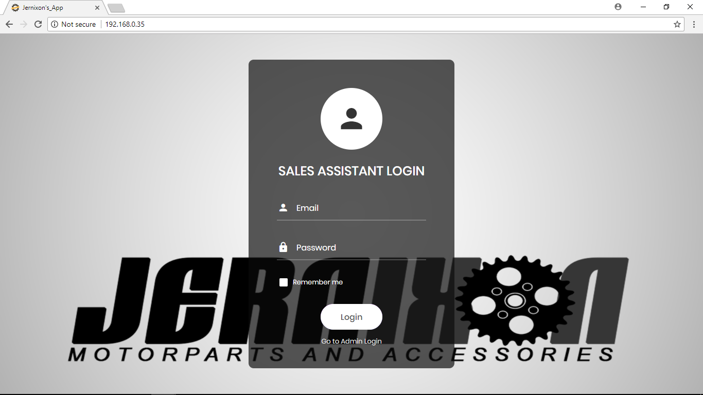

Figure 39: Sales Assistant Login

**Sales Assistant Sales Items -1**

In the sales assistant’s sales item, the sales assistant can sell items to the customer. The sales assistance can search items and see details of the items. The details of the items are description, quantity in stock, selling price.

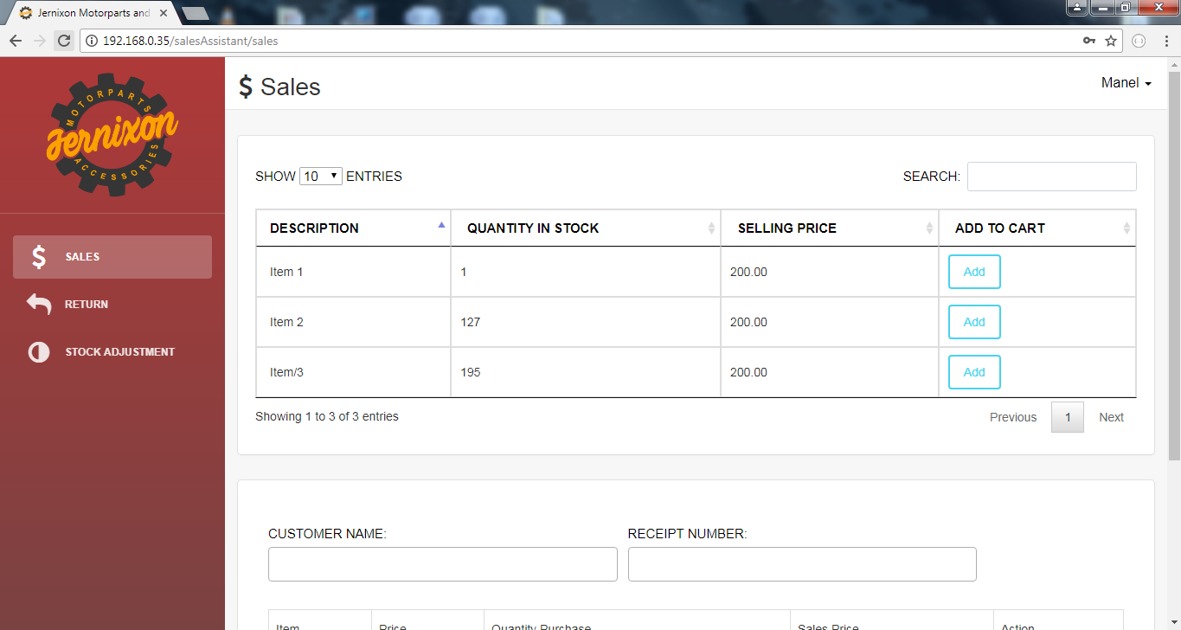

Figure 40: Sales Assistant Sales Items 1

**Sales Assistant Sales Items - 2**

Figure 37 shows the details needed to be fill up for the purchase of the customer. To add an item, the sales assistant needed to click the button Add. Then the item will appear below the customer name. The added item shows the price, quantity needed to be purchased by the customer, price of the item multiply by the quantity purchased and the total price of all item that will be purchased by the customer.

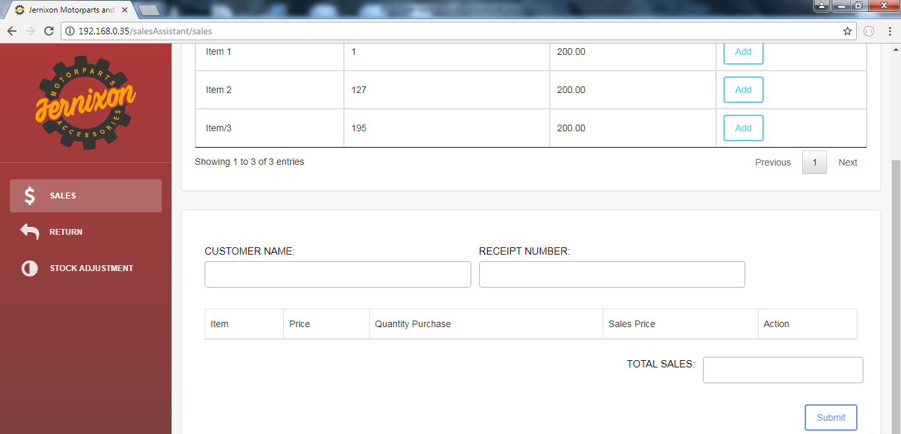

Figure 41:Sales Assistant Sales Items 2

**Sales Assistant Return 1**

The sales assistant return shows the items return by the customer. The details shown are the official receipt number, date created and more details are shown when the view button is clicked.

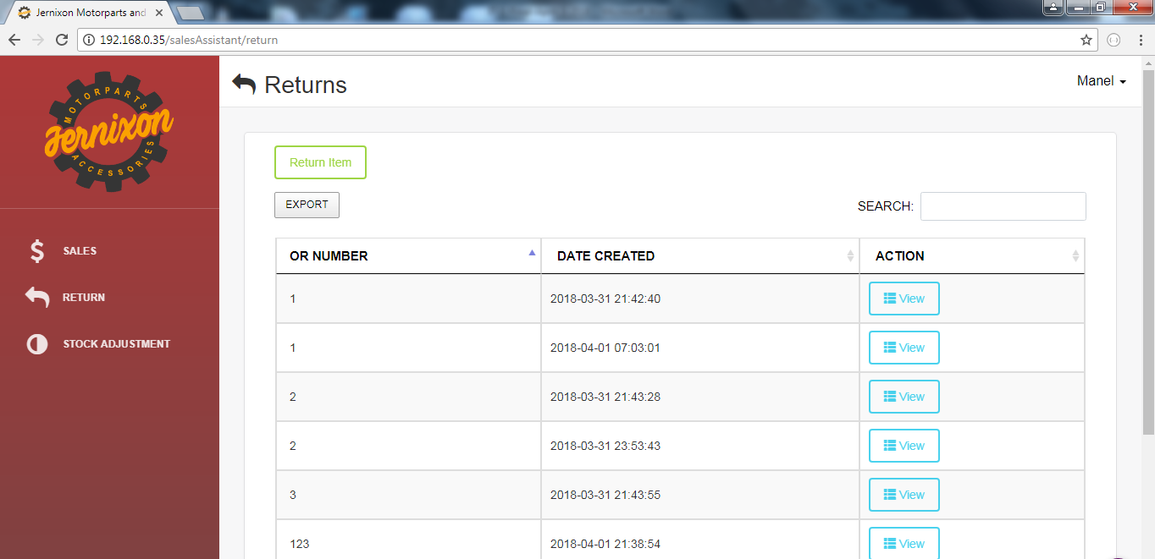

Figure 42*: Sales Assistant Return 1*

**Sales Assistant Return 2**

After the view button was clicked, details of official receipt are shown. The details are the date of OR, official receipt no., customer's name and the items that are return.

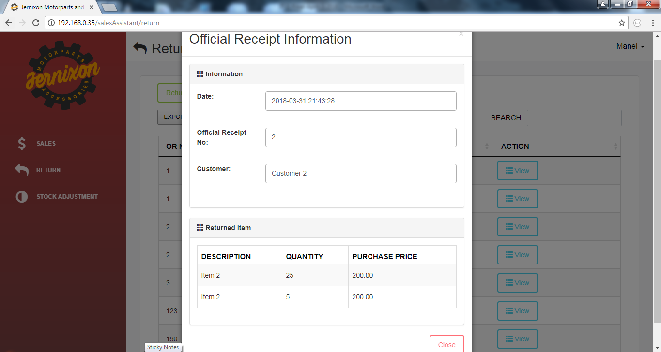

Figure 43:Sales Assistant Return 2

**Sales Assistant Return 3**

When return item button was clicked, ~~return~~ a modal will open. Official receipt no. is needed for the other details such as customer name, date and the return item to appear. The damage item can be exchanged with different type of item but the item cannot be refund. If the exchanged item ~~have~~ has a higher price then the customer will pay for the remaining amount.

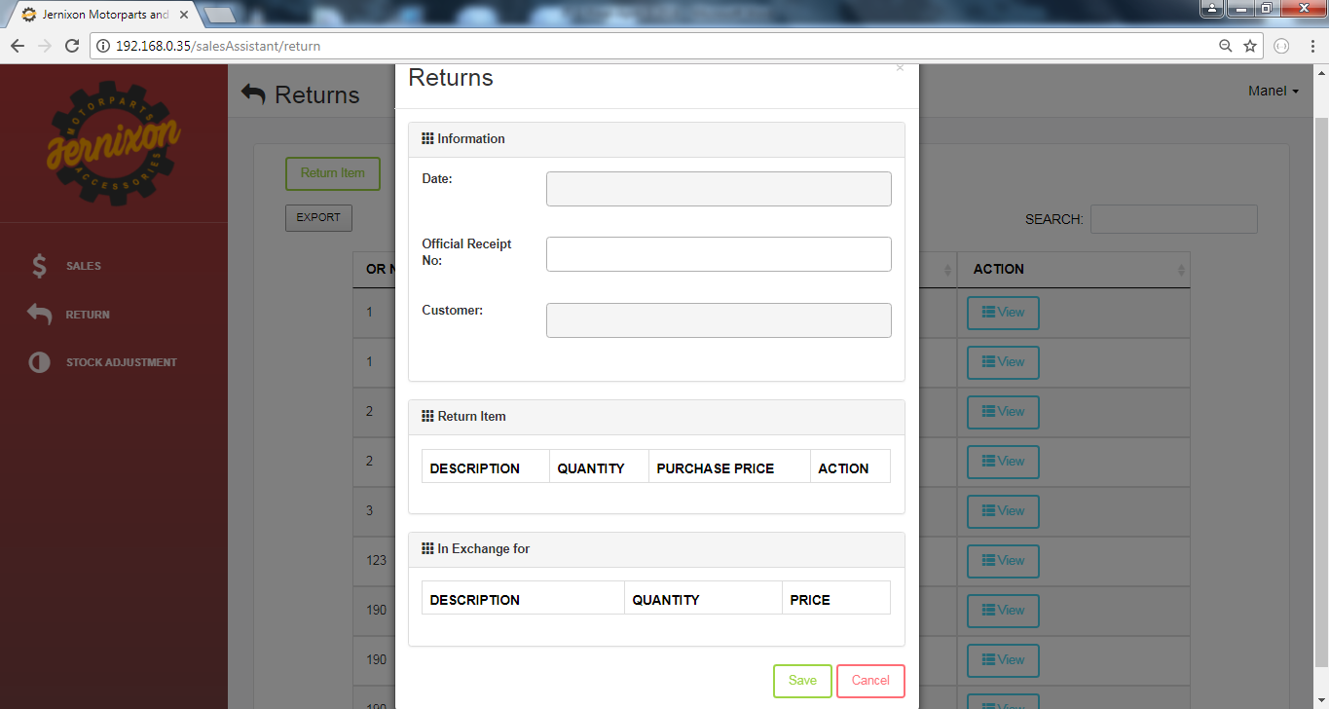

Figure 44: Sales Assistant Return 3

**Sales Assistant Stock Adjustments 1**

The stock adjustments shows the details of items that are adjusted. The sales assistant can also adjust stocks. The Stock Adjustment button shows the form where the sales assistant can search an item that will be adjusted and some detail will be filled up by the sales assistant.

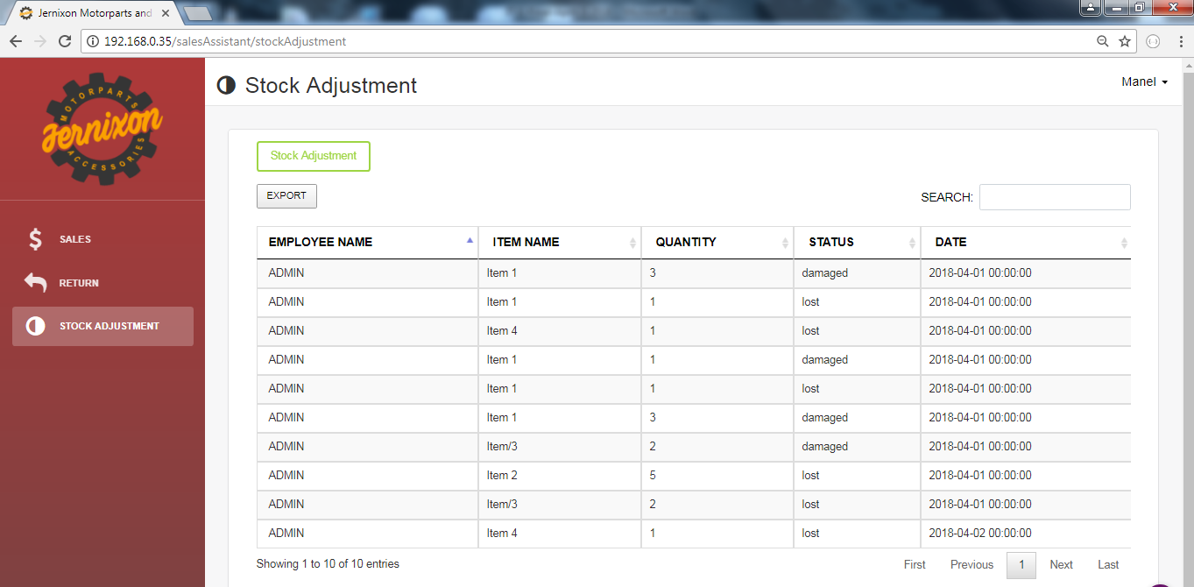

Figure 45: Sales Assistant Stock Adjustments

**Sales Assistant Stock Adjustments 2**

When the stock adjustment button is click, a form consisting of date, search box, and details of items will appear. The search box is used to search items and when the sales assistant chose an item, the details will be shown in the table.

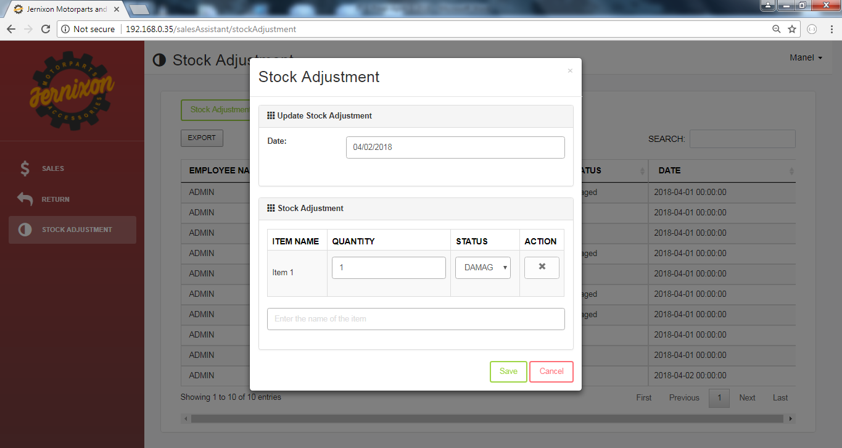

Figure 46: Sales Assistant Stock Adjustments

**Sales Assistant Physical Count**

The physical count will only appear when the owner will activate it. The physical count is about counting the items in the stock room and the sales assistant will input the details to the application.

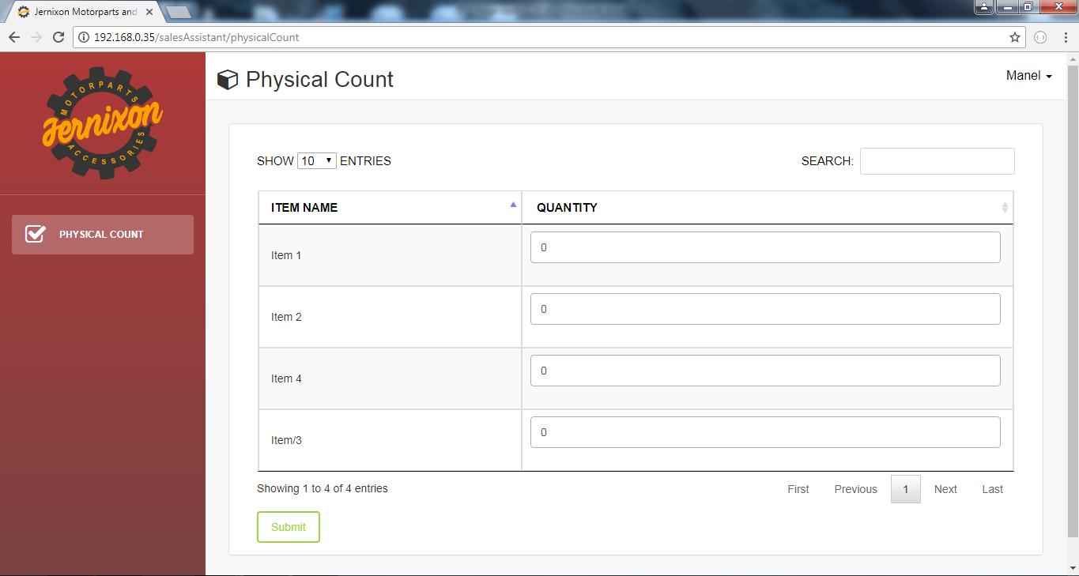

Figure 47: Sales Assistant Physical Count

## 3.3 Development and Testing

Table 4 and 5 shows the tools and technologies that will be used by the project team in developing the system. The project team picked those tools and based on how knowledgeable they are in using the development tools.

### 3.3.1 Development phase tools

Table 4: Development phase tools

|  |  |
| --- | --- |
| Software tools | Description |
| brackets.jpgsublime.png | Source code editors.  Used as a tool edit or create file that will be used in the project  Sublime, Notepad++, Brackets, Visual Studio Code - Text editor for HTML, CSS, Javascript, PHP and other type of file. |
| github.png | Online repository  Enables the group to store codes online.  GitHub - An online repository which usually used for computer program. |
| php.png Image result for apache icon Image result for my sql icon | PHP, Apache and MySql  Php - A server side scripting to create dynamic web page.  MySQL - A visual tool for the database  Apache - an open source web server. |
|  | Browser.  Where web application can display it's content. |
|  | Mock up tool is used to create mock up design for the web application.  Balsamiq - Used to create wireframe of the user interface. |

### 3.3.2 Development phase technologies

Table 5: Development phase technologies

|  |  |
| --- | --- |
| Development Phase Technologies | Description |
| Image result for js icon  html5.pngcss.png  bootsrap.png  Image result for jquery icon | Front end technologies.  Used to create the design and structure of the website  HTML5 - Structure of a web application  CSS - Used for creating the design of the website.  Bootstrap - An open source library for designing web application and websites.  JS - Used to make an interactive web application  Jquery - Javascript library that simplifies the complicated things from the Javascript. |
|  | Back end technology and framework.  Used to create the backend of the web page.  Laravel- A php framework to help build website easier and faster. |
| wampserver.png | Web development platform.  A server that runs database, php and other web application component.  WAMP server - A server which can be used for creating and testing web application |
| Image result for mysql workbench iconphpmyadmin.png | Database management is a tool to create, edit and delete database. |

### 

### 3.3.3 Hardware

Table 6: Hardware

|  |  |
| --- | --- |
| Hardware | Description |
| Image result for laptop icon  Laptop | Laptop  A device that is a portable computer.  The business will use the owner's laptop to access the inventory system. |

### 3.3.4 Timetable and Roles of members

The time table figure 38 will be followed by the project team in developing the project for the business. The project team also included the daily schedule in making the project.

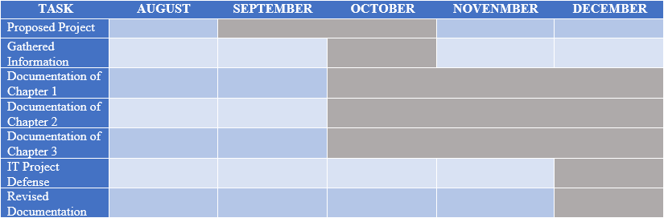

Figure 48: IT Project 1 Schedule

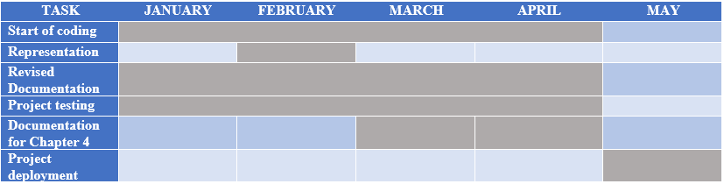

Figure 50:IT Project 2 Schedule

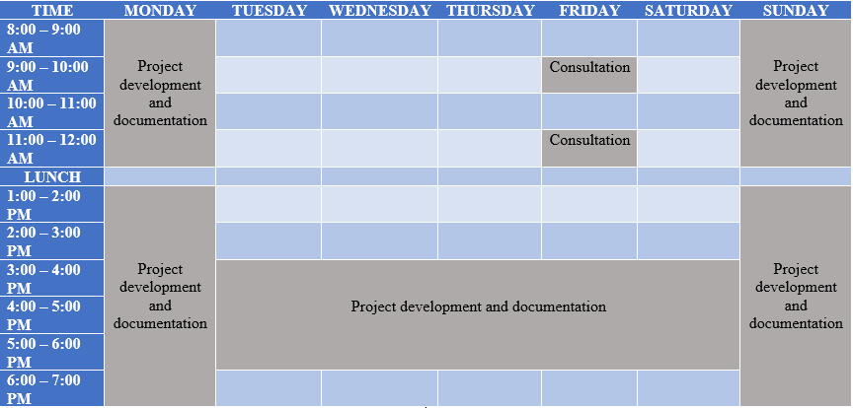

Figure 51: Timetable

Figure 47 is the specific roles assign to each member of the project.

|  |  |  |  |
| --- | --- | --- | --- |
| **D:\Bootstrap\6.png**  **Abalos, Joshua James** | **D:\Bootstrap\3.png**  **Antero, Randy** | **D:\Bootstrap\8.png**  **Baucas, Marinel** | D:\Bootstrap\1.png  **Cabilar, Nonito** |
| Project Manager, Documentarian | Lead Database, Programmer | Designer, Documentarian | Designer |
| **D:\Bootstrap\7.png Carreon, Engelyn** | **D:\Bootstrap\5.png**  **Jaramel, Kenneth** | **D:\Bootstrap\2.png**  **Manzon Jake James** | **D:\Bootstrap\4.png**  **Romero, Caesar** |
| Designer, Documentarian | Designer,  Lead Tester | Lead Programmer | Lead Designer |
|  |  |  |  |

Figure 52: Specific Role of the members

### 3.3.5 System Testing

The project team test the application and found bugs but the programmer fixed some codes to eliminate the problem. The tester test if all functions are working and also test if the design is responsive. The development of the project may have a lot of bugs but in the later stage of the development, bugs are eliminated. The tester ensures if the data that are being shown is correct. The project team will manually test the system to test if all the function of the system ~~are~~ is working.

# 3.4 Deployment of the System

# Chapter 4: Conclusion

## 4.1 Conclusion

The business is a retailer shop that sells motorparts and accessories. The group developed a web-based inventory system for the business, where the owner and sales assistant can track and manage the items in the inventory.

To establish a successful application, the project team analyzed the current system and transaction of the business, then listed down the problems that the business encountered, identified the objectives and requirements of the application, designed, identified the roles and time of the project, developed and deployed the system.

In the development of the system the problems that the project team encountered are the bugs while developing the system, conflicts while doing commits in the Github, and the design of the application is not responsive.

### 4.1.1 Recommendation

To further improve the system, it is recommended to add a reservation system for the customer when an item is out of stock. In the reservation system, when the item is out of stock the customer may leave their contact information and once the item is available, the application will notify the owner to contact the customers.

If the business flourish and expand with more branches, it is better to make an online inventory system to have a centralized system. The owner will have a better idea on what's going on the sub branch.

# References:

[1] F. Robert Jacobs and Richard B. Chase (2013).Operations and Supply Chain Management: The Core, 3/e. United States of America;McGraw-Hill/Irwin.

[2] Kotler, Philip., & and Armstrong, Gary. (1999). Principles of Marketing. Canada:Prentice Hall

[3] Nations, Daniel.“Web Applications”. Retrieved November 09, 2017, from <https://www.lifewire.com/what-is-a-web-application>

[4] [Joseph Brylle N. Cambronero](https://ejournals.ph/function/author.php?id=6618) et al. “Integrated Sales and Inventory Management System Implemented In Three-Tier Architecture”. Retrieved November 12, 2017, from https://ejournals.ph/article.php?id=6125

[5] What is a Web-Based Application? - Definition from Techopedia. (n.d.). Retrieved November 09, 2017, from https://www.techopedia.com/definition/26002/web-based-application

[6] Introduction to web applications. Retrieved March 5, 2006, from cs.lmu.edu/~ray/notes/webapps/

[7] ["Waterfall Software Development Model"](http://www.oxagile.com/company/blog/the-waterfall-model/). Retrieved November 10, 2017, from https://www.oxagile.com/company/blog/the-waterfall-model

[8] [Craig Hockenberry](https://alistapart.com/author/craighockenberry) (2010, August 17). Apps vs the Web. Retrieved from <https://alistapart.com/article/apps-vs-the-web>

[9] Doaa Nabil et al. "Web-Based Applications quality factors: A survey and a proposed conceptual model". Retrieved November 23, 2017, from http://www.sciencedirect.com/science/article/pii/S1110866511000405

[10] "Zoho Inventory System". Retrieved March 22, 2018, from

<https://www.zoho.com/inventory/#/integrations>

# Attachment/Appendix

## Appendix A: Transcript of Interviews

**Legends:**

**Owner:** Mr. Romeo Nacar

**Interviewer:** Joshua James A. Abalos

**Start of Transcript**

**Interviewer:** How do they order? (supplier to owner and owner to customer)

**Owner:** The owner will send an email to the supplier that contains the name of the items, quantity of items to be deliver and the date for pickup. Sometimes the owner will go to the supplier’s location to buy items.

**Owner:** They buy accessories twice a week and weekly for the motor parts.

**Interviewer:** How does the owner order to the supplier? Is there an inspection before the item will go to the stockroom?

**Owner:** If the items are delivered, the owner will inspect the items. If the owner personally orders the products from the manufacturer, both the owner and the supplier will inspect the item.

**Interviewer:** How do they give warranty to the item (supplier to owner, owner to customer)?

**Owner:** The owner has 1 month warranty after the item has been bought from the supplier. Example of this is a battery, it has 1 week warranty and if the battery has a defect it can be return to the supplier especially if it is a factory defect.

**Owner:** If it is a transaction between the owner and the customer, the customer will have 1 week warranty. The customer usually checks the item before buying it therefore it is rarely returned. If there are returns before the warranty expires, the customer should present their receipt and the return items can be changed but it can’t be refunded. There are cases that customers are the one who broke the items so the damaged items are not accepted to change. The return items can’t be refunded but it can be change. If the customer accidentally damages it, the owner will not change it.

**Interviewer:** How do they know if an item is out of stock?

**Owner:** They manually check the items to know if there is an item that is out of stock.

**Interviewer:** Do the main branch and the other branch has the same business process?

**Owner:** Yes

**Interviewer:** How often customers arrived?

**Owner:** Customers arrived during the afternoon

**Owner:** Most customers go to the shop during holidays and weekends, especially when there is an upcoming motor shows.

**Interviewer:** How many transactions in one day? Average?

**Owner:** Minimum – 15 transactions

**Owner:** Average - 30-40 transactions

**Interviewer:** How they keep track of the items in the stockroom?

**Owner:** They manually check the items in the stockroom.

**Interviewer:**  How do they know if they need to order?

**Owner:** If the owner realized that the specific item is in demand, he manually checks the items in the stockroom and that’s the only time he will realize that he needs to order or not.

**Owner:** They order every week and those items that so in demand, that’s the item they ordered often. They also manually check the items in the stockroom.

**Interviewer:** How do they do their inventory? Is it inventory count only?

**Owner:** Items that are sold and its quantity are written manually. At the end of the day, they do physical count of items. There is no list of all the items and the quantities so they only refer to the sales and physical counting.

**Interviewer:** What is the problem to their current system other than inventory count?

**Owner:** It is better to use computers or technology when checking the inventory rather than the usual manual checking.

**Owner:** When supplies are being ordered, the items are checked manually in order to know when to order new items again.

**Interviewer:** What are the reports to be generated?

**Owner:** Items that are in critical and items that has great number of stock will included in the report

**Interviewer:** Number of suppliers

**Owner:** Parts – 5 , Accessories – 8

**Interviewer:** Total number of products they sell

**Owner:** Estimated: 500 to 600 items

**Interviewer:** Best seller item

**Owner:** The best seller items are tire, tube, sprocket, oil and chain

**Interviewer:**  Re-order level of the items?

**Owner:** 5 items below needs to be prioritized especially those items that are being delivered since deliveries only happen once a month

**End of Transcript**

**Mr. Romeo Nacar**

Owner/General Manager

## Appendix B: Delivery receipt

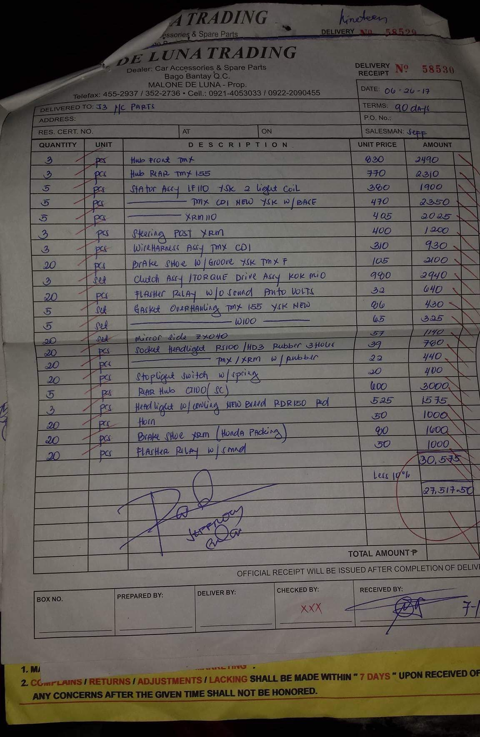

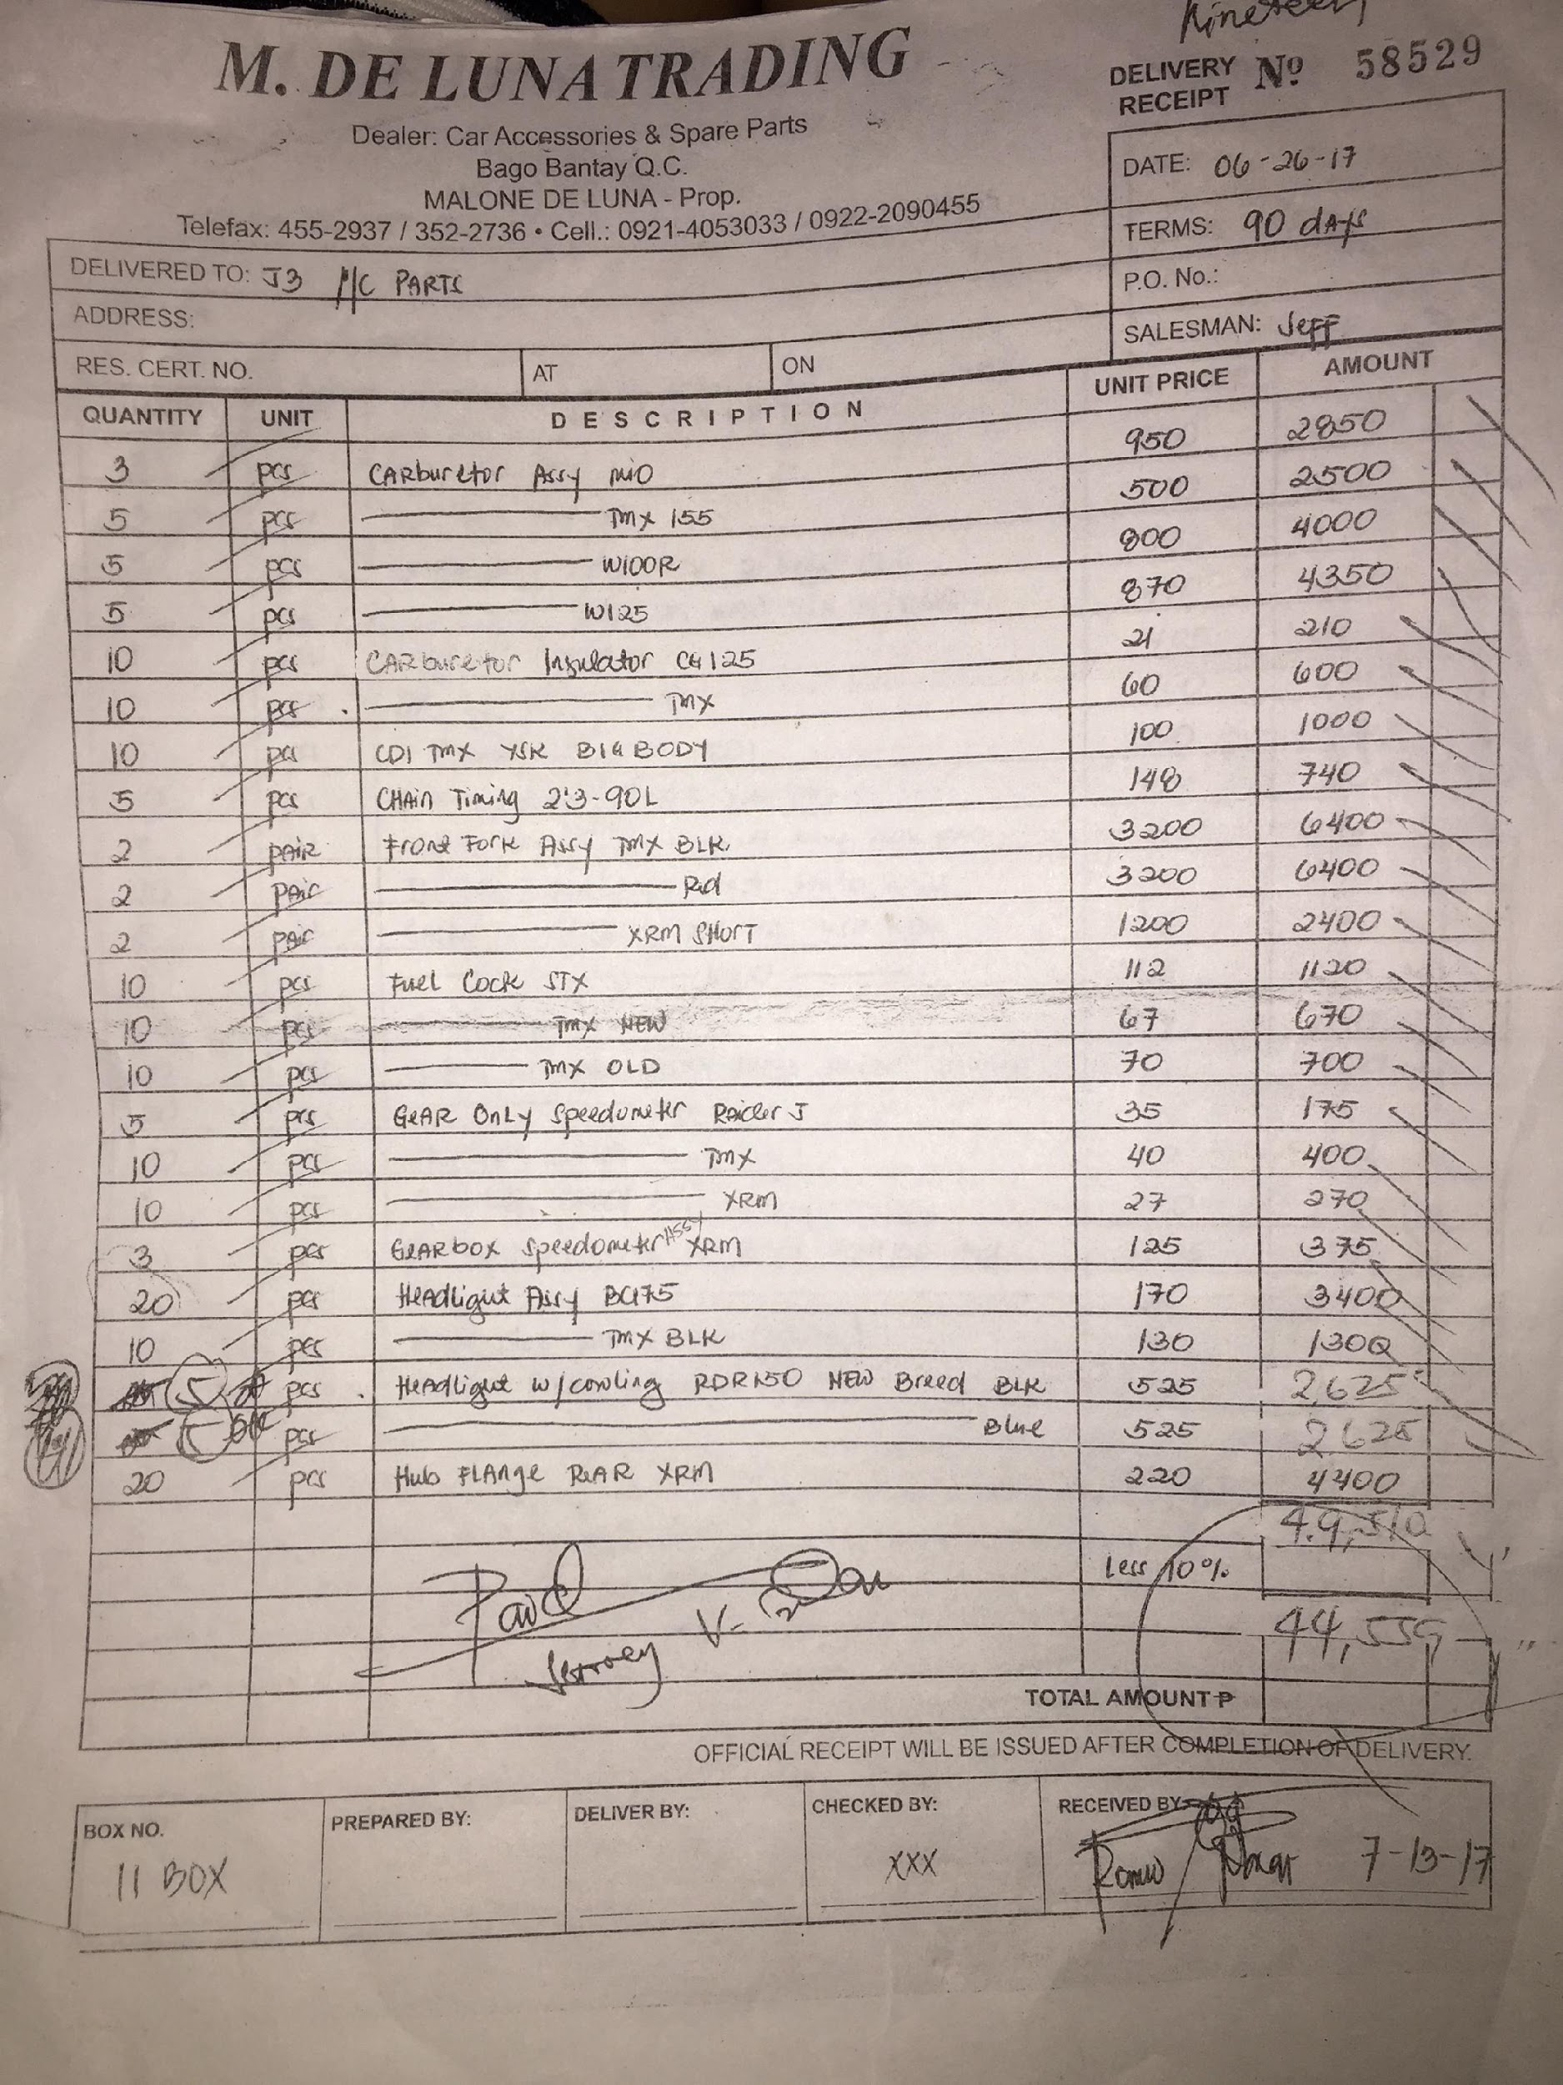

## Appendix C: Invoice receipt by supplier

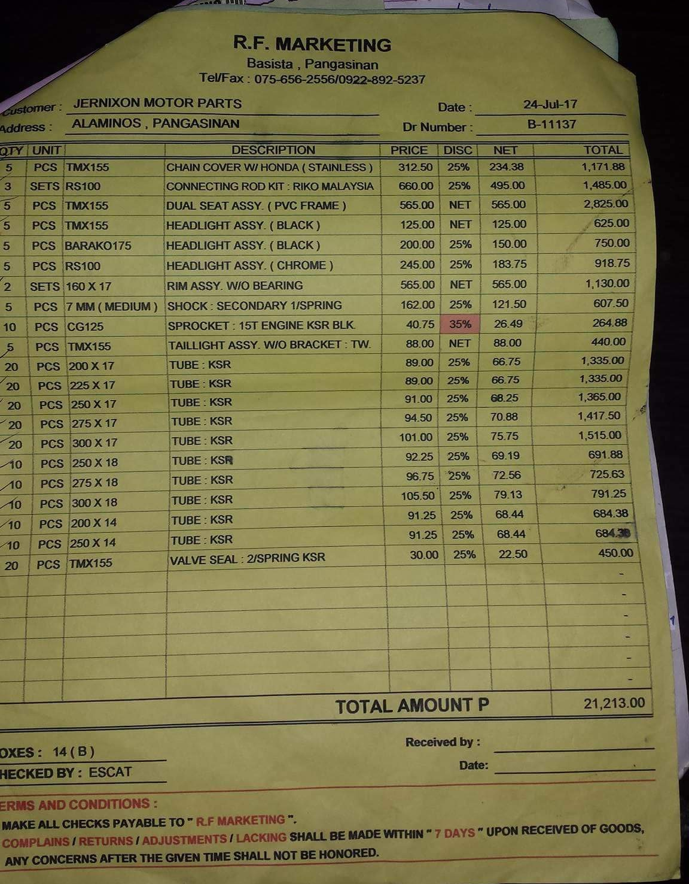

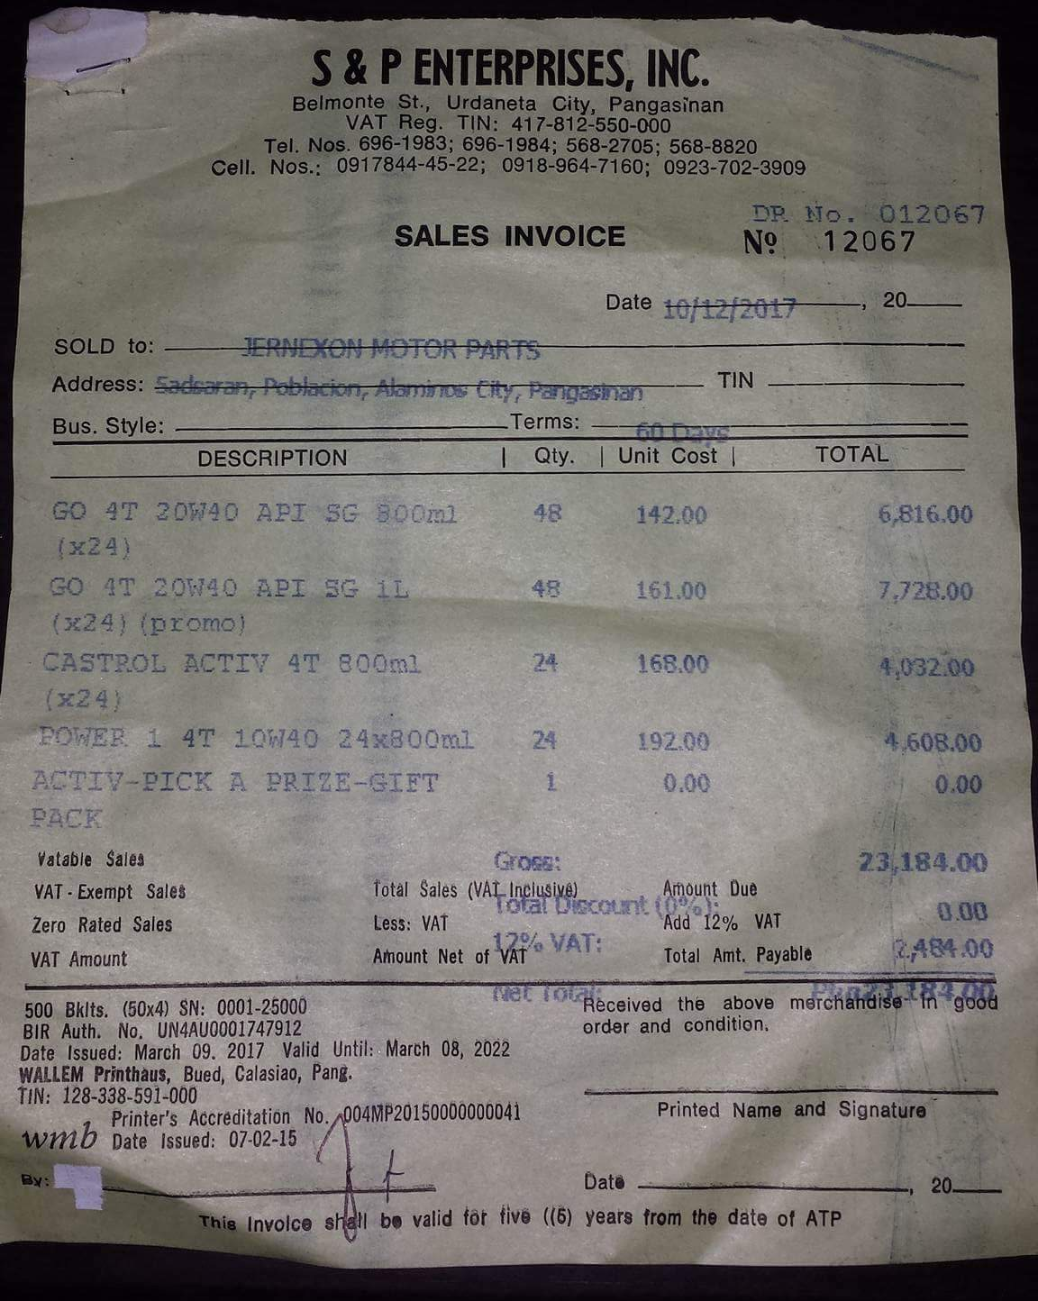

**Appendix D: Official receipt**

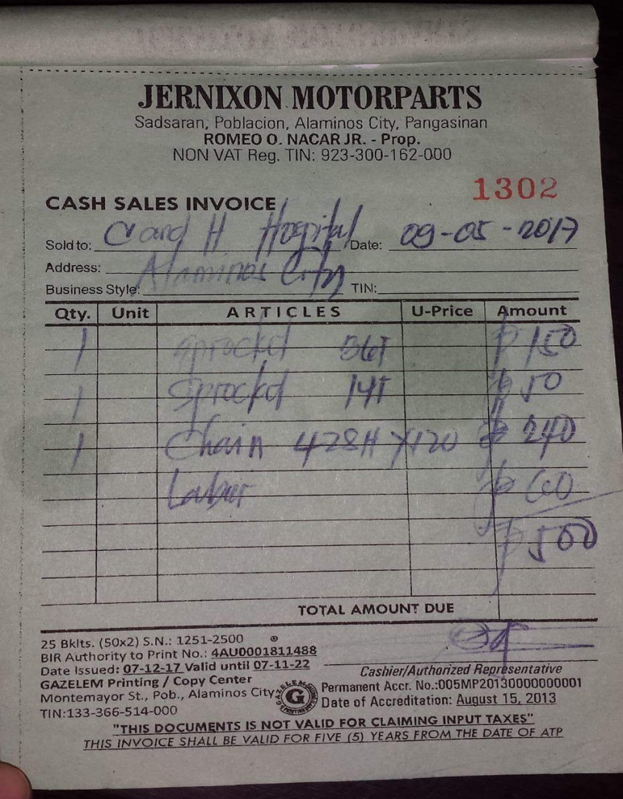

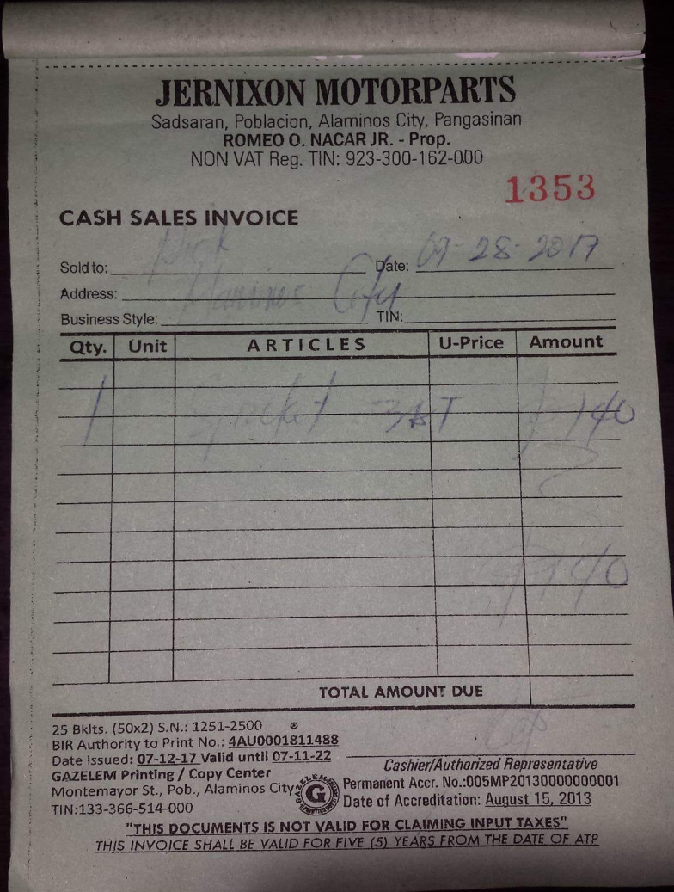

## Appendix E: Sample list of products

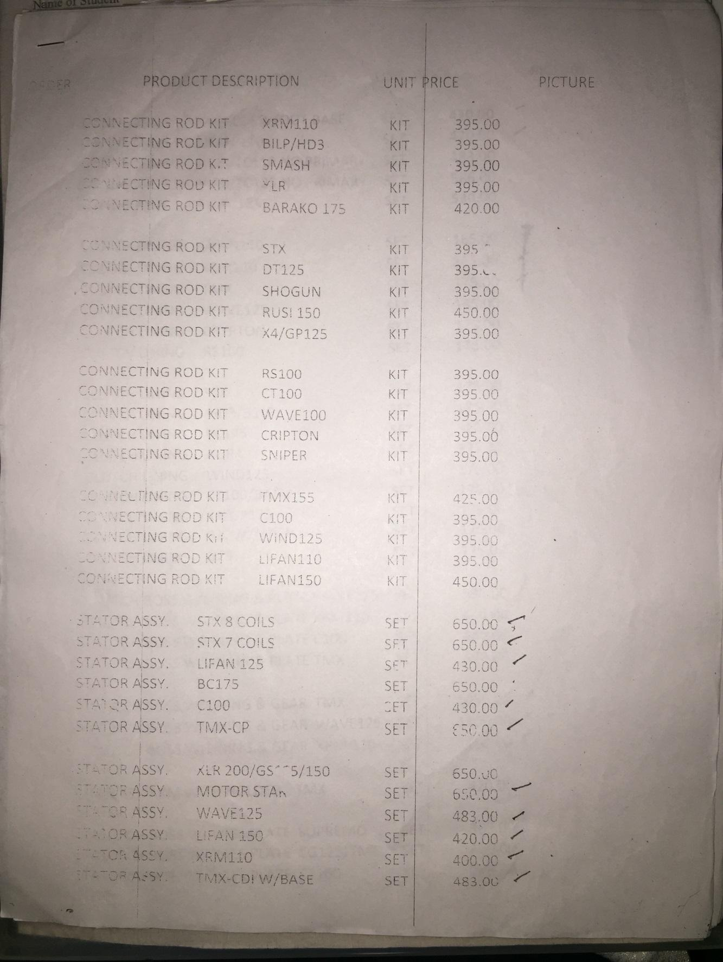

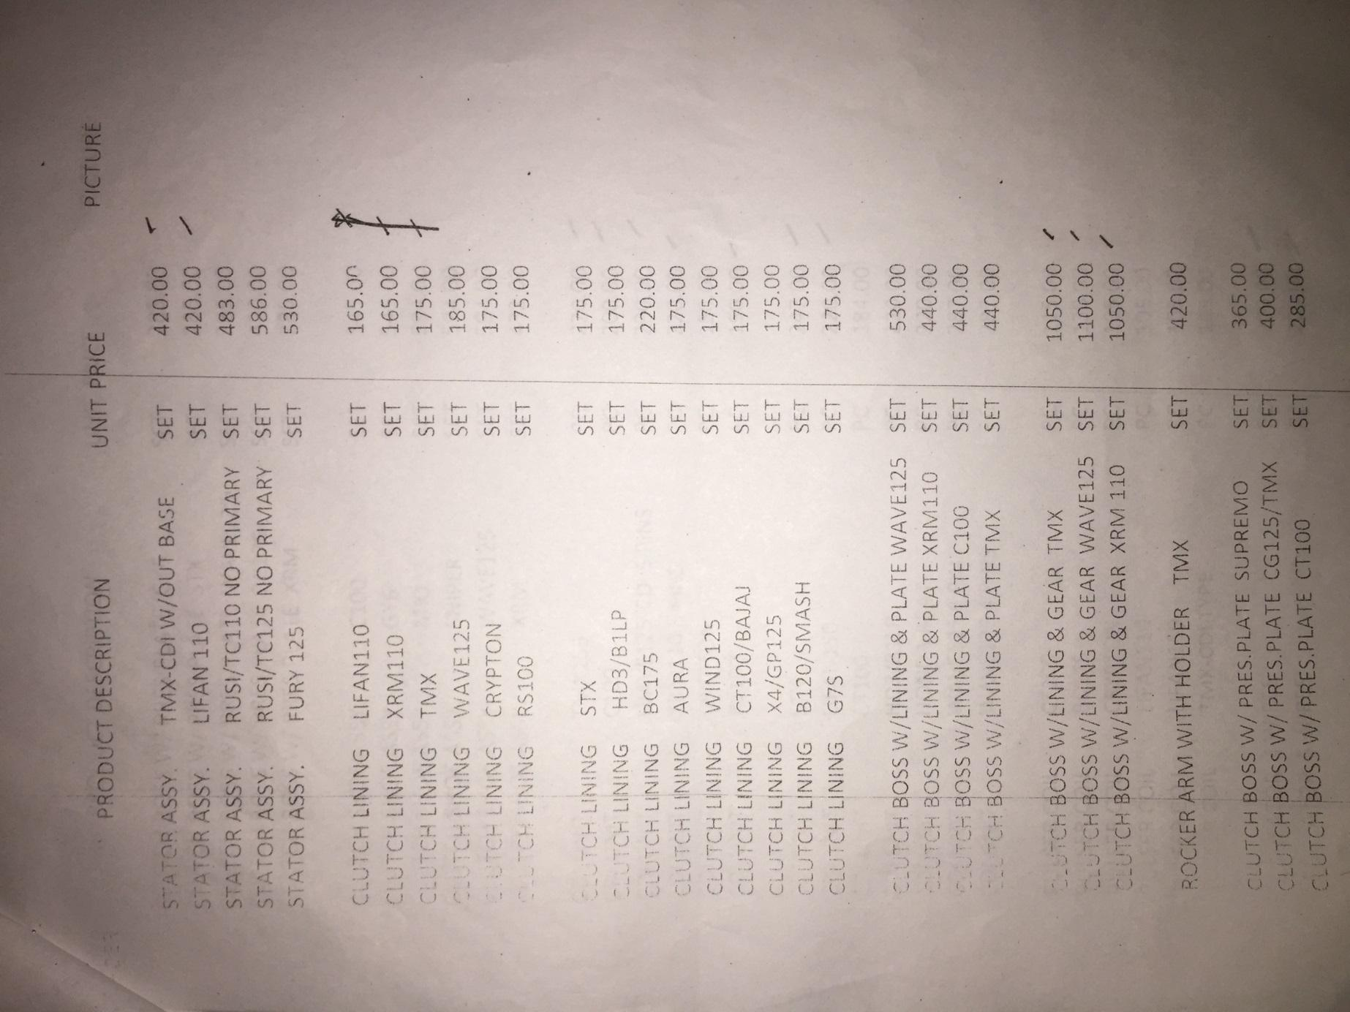

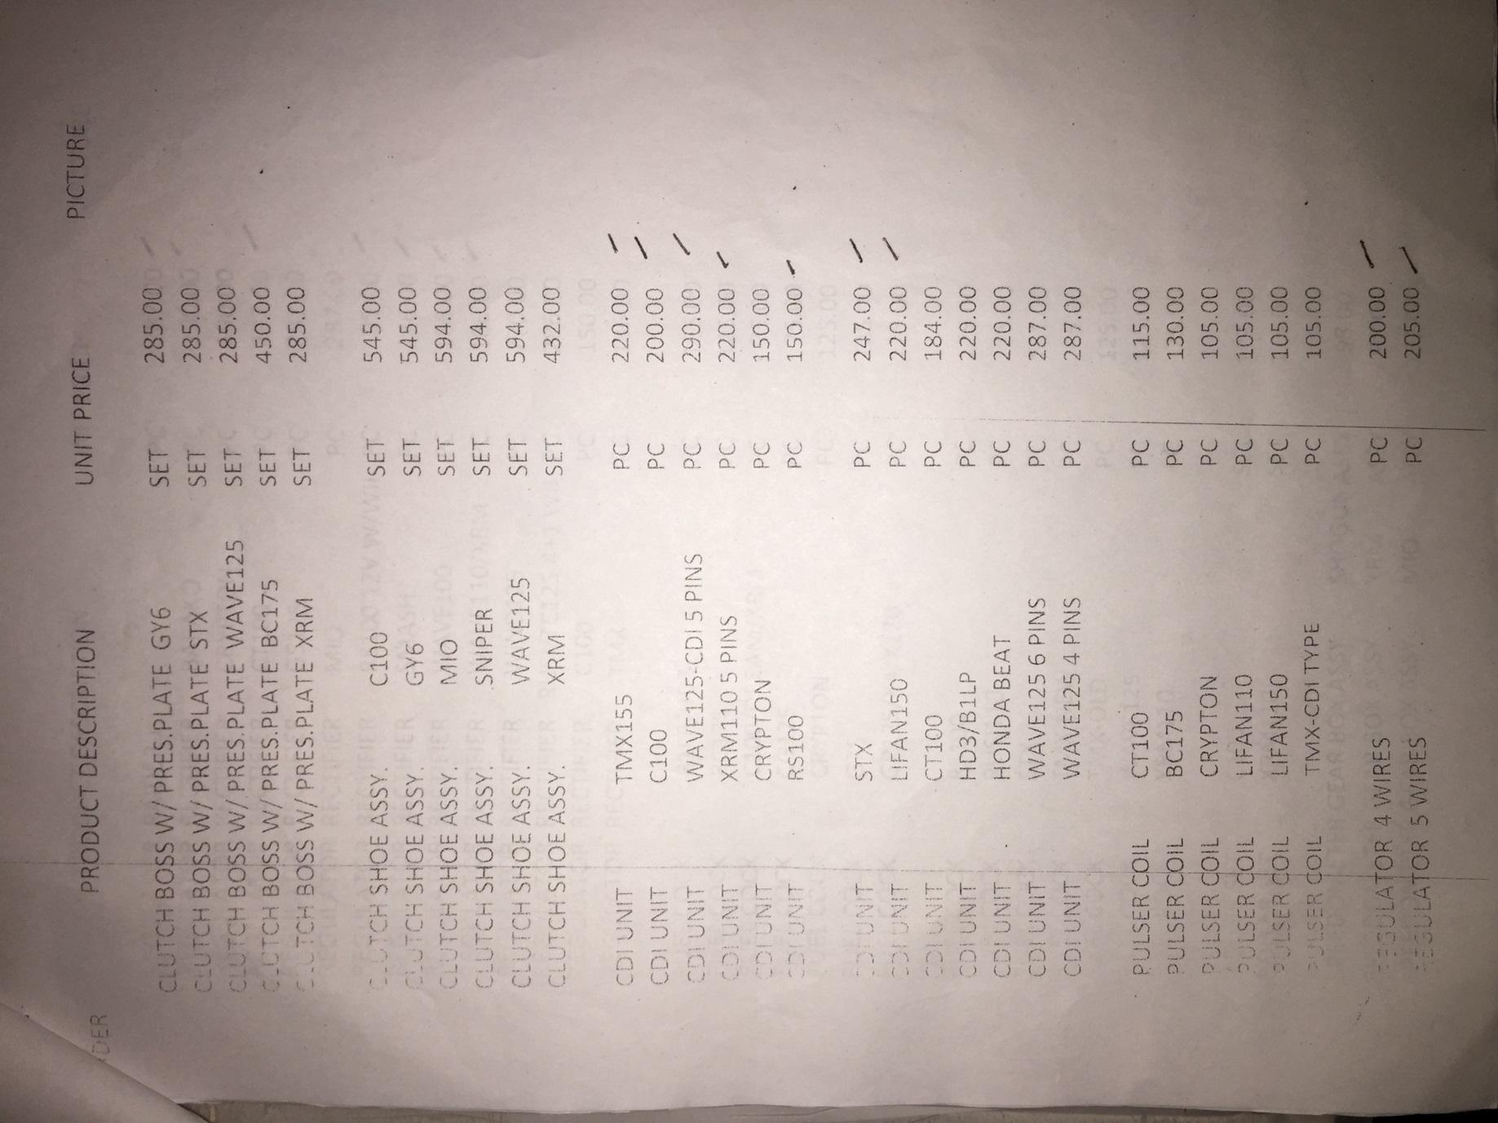

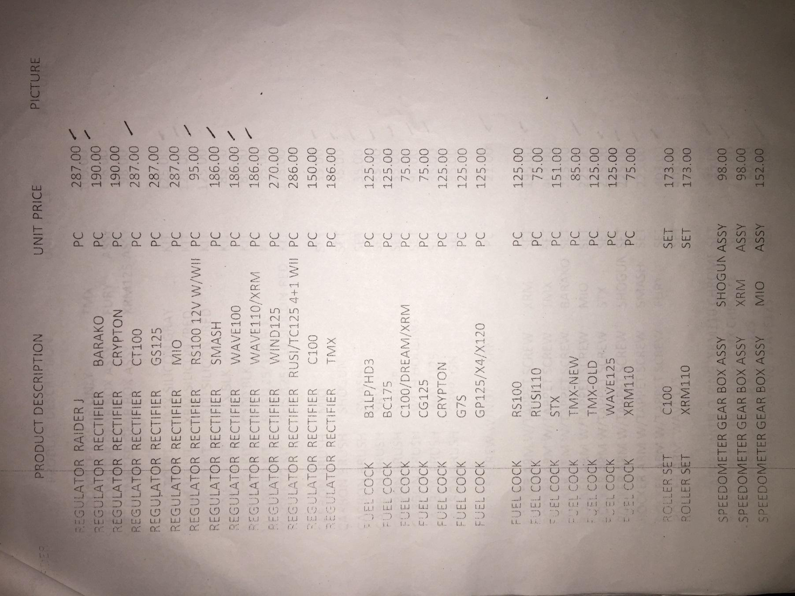

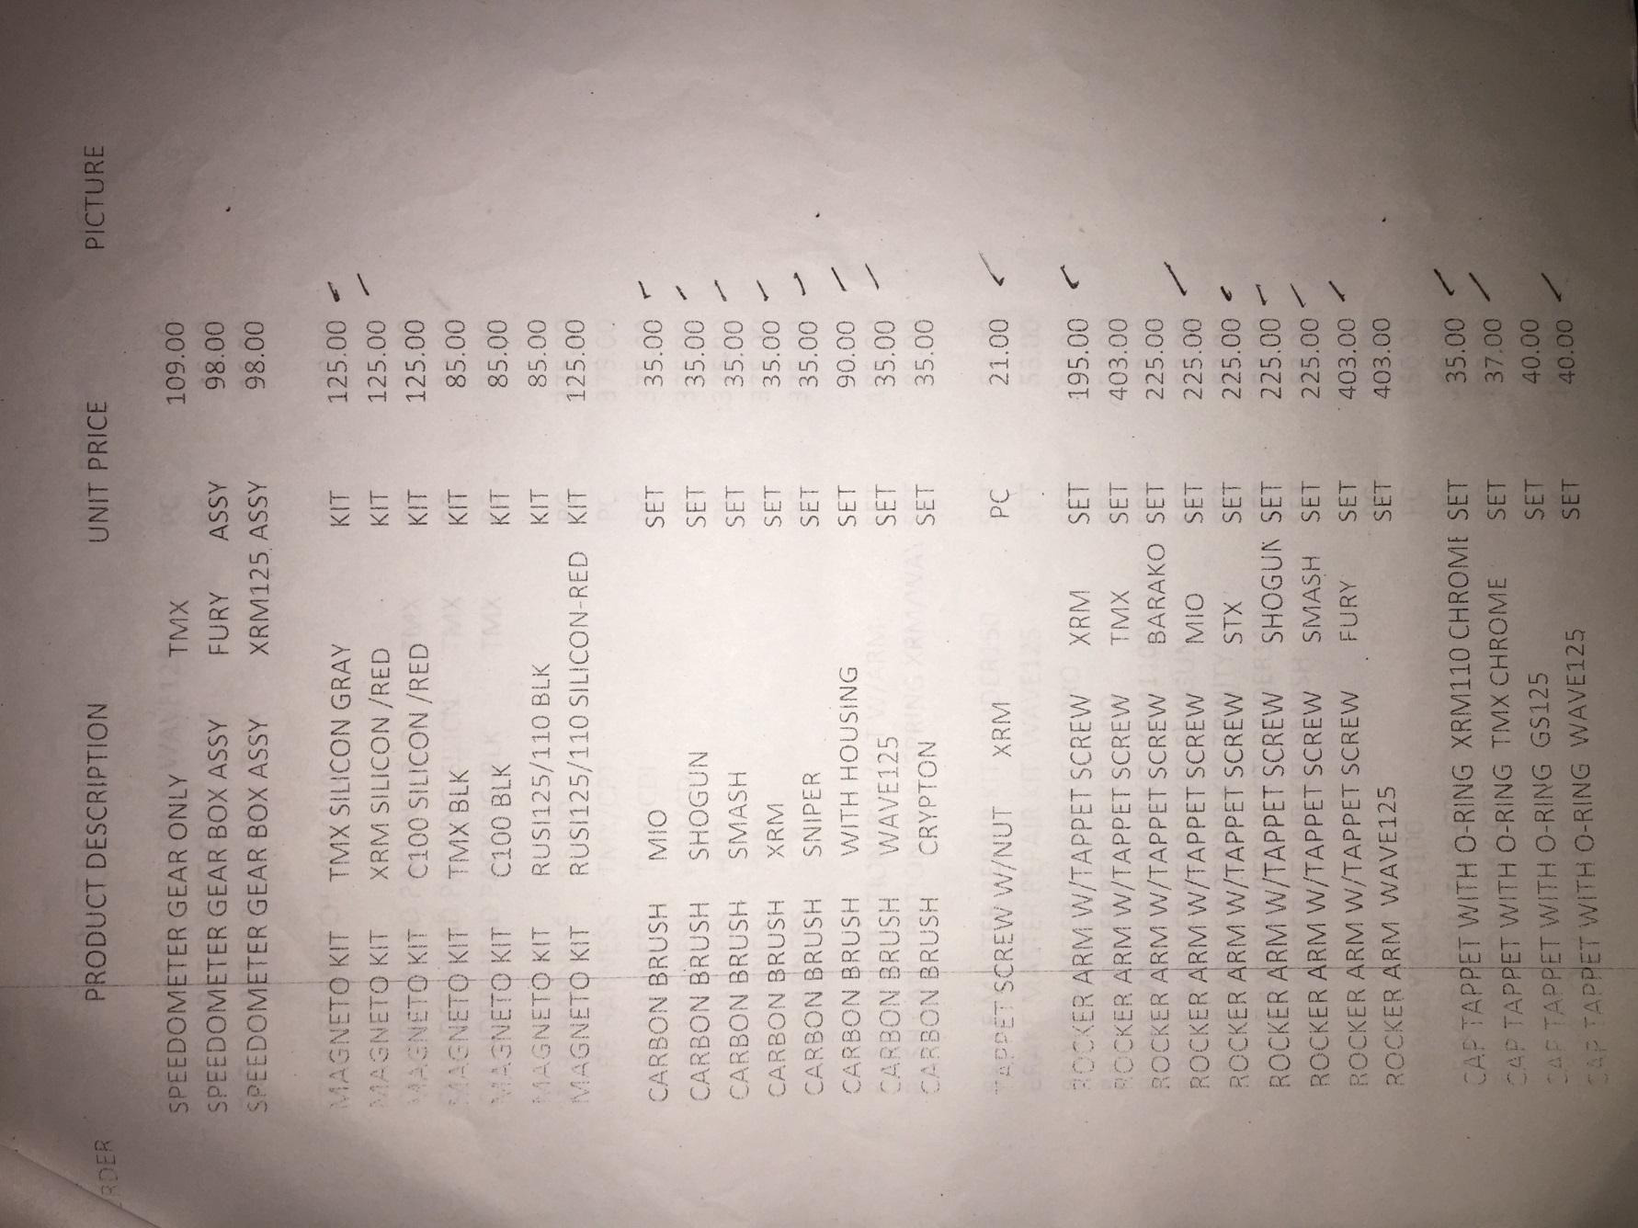

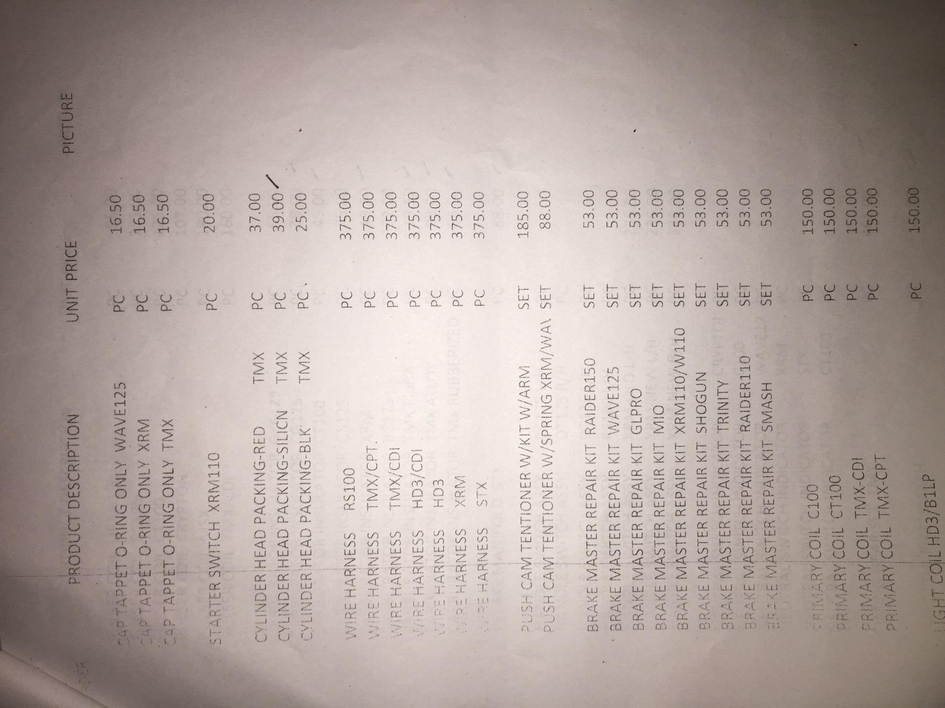

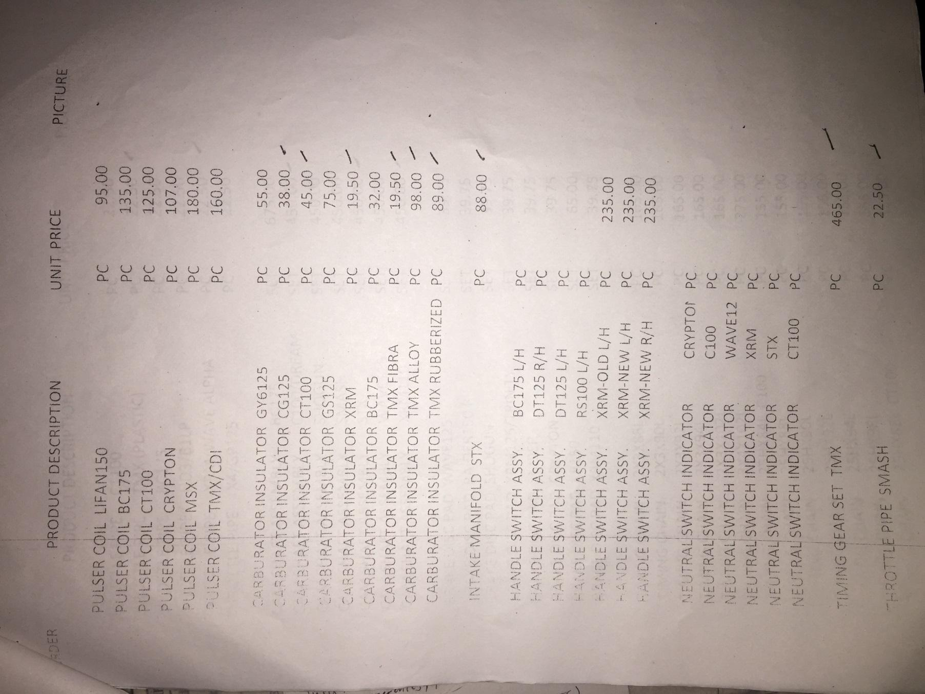

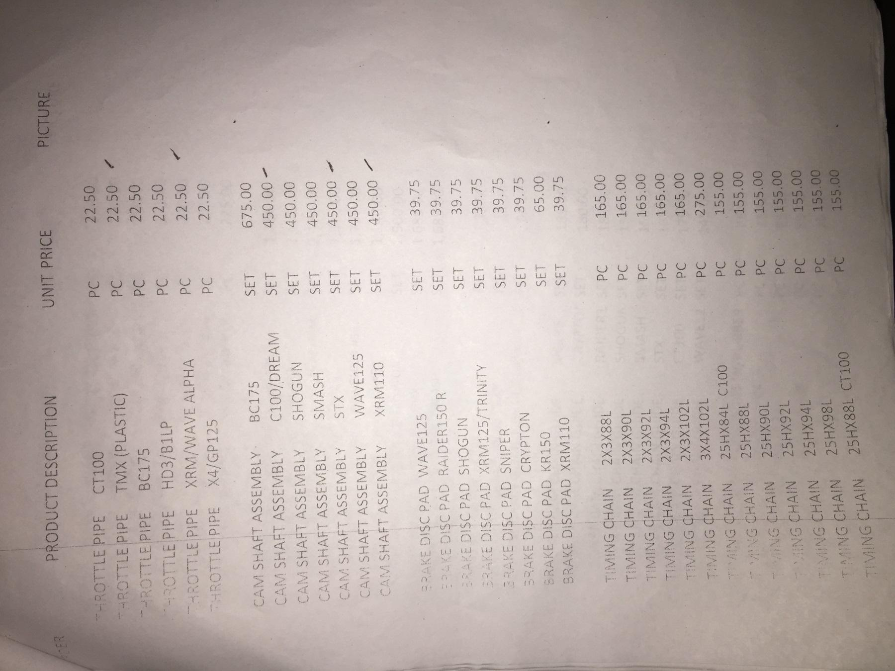

## Appendix F: Sales list



